Media credits list http://research.ncl.ac.uk/romtels/resources/tech/
Enquiry 2 – Ancient Baghdad/Mesopotamia
SECTION | DESCRIPTION | THUMBNAIL | CREDITS
 | driving through Baghdad | Video | https://www.youtube.com/watch?v=0Cu1eDVE3M4 Defense Inc. video, Creative Commons attribution
 | modern Baghdad airport | 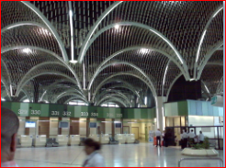 | https://www.flickr.com/photos/therachelmaddowshow/4911434319/in/photolist-Woxa-8u1oj4-jLGGQT-5Rt1kM-8XyTCC-4vTdz-ecgQH8-8vbq4b-5GwfPP-2hfAcj-7fq81i-b6jWA-5ShEuX-6qRWqo-zBBxB CC (CC BY-NC-ND 2.0) by https://www.flickr.com/photos/therachelmaddowshow/
 | Ziggurat of Ur – use for temple? | 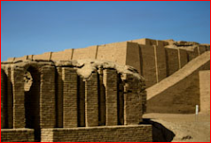 | https://www.flickr.com/photos/patissier73/2464309219/in/photolist-4KLegZ-c1VwXj-a1pNze-c5D6T5-6PACWs-PHsdS-6Pww6r-bA8zrZ-6PwrCk-6Pwt2a-973zSt-eesAPC-9tCGe-7GXajy-6P2ryB-976rub-6P2mfv-amN1BU-dj3mwQ-7bMqyD-ukd7r-6P2kY4-fz6tq9-6P2rYF-976UKo-966jdE-4eAwFB-6xoUPC-5DU7BQ-jkJUy-6P2pzt-5xMMrH-ufNxx-976U54-5xMLXn-8DtHoC-6CHQC1-ukffj-5Yx5yi-976xdU-ukdMW-976TQf-962u1e-9LBXVF-5TB7Mn-6BTo3x-dnXXvj-698gc5-qGWsUj-ukfz2 CC (CC BY-NC-ND 2.0) by https://www.flickr.com/photos/patissier73/
 | Archaeological dig | 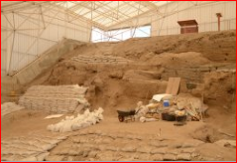 | https://www.flickr.com/photos/david55king/1291841479/in/photolist-2Ya2sX-bZuixd-4xb3LY-9DBhn1-5GUY7y-4JGrMv-5GUYAj-2b6KKC-GW7Q6-e68F4a-a73bqm-9yvGBi-4TGTtu-EURzE-e6cEtd-f9pLGR-kvXLwU-bDF93n-e671RP-f9E8e9-f9pPrZ-9fr5rh-7F377C-7LhE2e-5SAMAi-2Ya5Hv-22rMwT-gbBzwd-eJiXPW-6bV7Dk-5acCTx-eJiQjL-eJiRGG-4SeUHV-eJcJFp-2Cq7d-kAcjMW-5GUXNq-4wDEBu-ovDijk-a87WBk-GgNcY-ozEaJc-7QVW6B-ptDvdT-4JYmsY-bYYbdm-oheXpZ-3idUQB-hBJXHg CC (CC BY-NC-ND 2.0) by Allison Mickelhttps://www.flickr.com/photos/17193322@N03/  NOTE: this is of a dig in Catalhoyuk, Turkey
 | Archaeological dig | 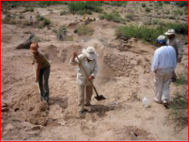 | https://www.flickr.com/photos/grand_canyon_nps/5975526544/in/photolist-a738RJ-a738rb-a7388w-a736aj-a6ZcRc-a735s7-a734Yq-a734r5-a6Zb6K-a731SG-a6Z8Pk-a731mS-a73153-aoacWd-aVhu3-hikEbq-qdWZxz-aoa9uA-a1ST3C-e4522g-dHjjV8-a1Q1Pv-a1Q1gH-cc2hTq-a1STHd-cvcNz1-f3rFS5-a85yE9-qcQyew-63w8eK-YEf7u-s2RFxq-s2Yunz-sGbA94-EFebj-5DHMFu-dCoNXV-a1Q15v-cvcSkq-8bzUJM-hBEdju-8pRvar-6hPxHN-ao7tcH-8muV55-8mrN3t-8muUF5-8WmZK3-8WmZ6A-fKu3Bu CC (BY 2.0 ATTRIBUTION) by Allyson Mathis/Grand Canyon National Parks Service https://www.flickr.com/photos/grand_canyon_nps/  NOTE: this is of a dig in the Grand Canyon, USA
 | Airport doors | 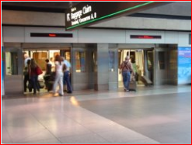 | https://en.wikipedia.org/wiki/Denver_International_Airport_Automated_Guideway_Transit_System#/media/File:DIA_Train_1.JPG public domain "DIA Train 1" by Sanibel sun at en.wikipedia - Own work (Original caption: “I created this work entirely by myself.”)Transferred from en.wikipedia to Commons by User:Jay8g using CommonsHelper.. Licensed under Public Domain via Commons - https://commons.wikimedia.org/wiki/File:DIA_Train_1.JPG#/media/File:DIA_Train_1.JPG
 | Newcastle airport video |  | - https://www.youtube.com/watch?v=OaA8BI4OMZw made with Creative Commons Attribution licence (reuse allowed)  by username Roger Nash
 | Aeroplane landing in Dubai video |  | - https://www.youtube.com/watch?v=1HbkIFD3tK4 made with Creative Commons Attribution licence (reuse allowed)  by username MrDjuiceman
 | Driving in Baghdad video |  | - https://www.youtube.com/watch?v=0Cu1eDVE3M4 made with Creative Commons Attribution licence (reuse allowed)  by username Erika Kerekes
 | Illustration of hanging gardens | 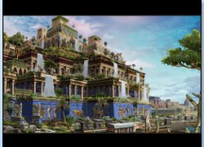 | https://www.flickr.com/photos/fantasy-art-and-portraits/7293719742 username Fantasy Art, CC BY-NC-ND 2.0
 | Ishtar Gate symbols on tiles | 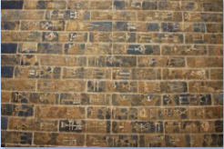 | https://www.flickr.com/photos/renaat/4163543839/in/photolist-7kVfwB-bmq4s4-7kYmvA-aA473Z-aA47BT-UgL5-UgKB-UgKf-aA4bvi-ynU5ed-xHtdyJ-98FpGy-98BtGz-98C8nc-98Bwvt-993bkn-98EQH7-98Fn5o-993jJV-98F8Fs-98Cb7n-98F6if-98FshE-98C2Te-ozY3KM-9QQT6F-9QQJ1p-9QQynx-9QQYAF-9QQN5k-9QQRda-9QTjqh-9QTyCf-9QQMeF-9QTgf9-9QR3Ra-9QTioh-9QRy4p-9QR1sz-9QTb6S-9QQZAP-9QTf1w-9QR2jK-9QTbUN-9QQQaK-9QQi7V-9QQTVZ-9QQtCZ-9QQvKM-9QR67B username Renaat, CC BY-NC-ND 2.0
 | Ishtar Gate animals | 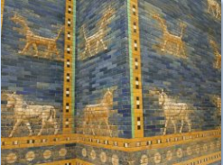 | https://www.flickr.com/photos/myrtti/5336983431/in/photolist-98BreH-98BoMK-4WVd2A-egFmoa-aA6PrE-eHpitt-eHphAg-eHvnBW-gVVD5H-ggQtu7-ggR5dh-hP4bTU-hP3LYZ-8ririJ-o5LbyQ-nNnYz5-byM2vo-byLZvs-bMFEHg-edzaST-o7DqWF-e7PepX-98BUuB-98F1rf-bUj9en-9QX3nC-9QUc2F-9HAG7N-8VXxPP-8W1BfW-a8UgPb-a93Zk1-ggR3YH-ggR1nD-9HxH1Z-9HABN1-gmHr7A-gmHSxh-gmJ5Vv-9QTXzf-ggQwwF-9HAE23-q1BcvL-4ks4Vi-oydj7V-a919D2-pYnSNN-oxVHUK-67cZzm-q1tokF username Miia Sample, CC BY-SA 2.0
 | Iraq archaeological dig | 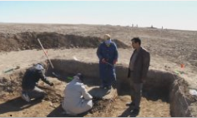 | Screenshot from film Digging Out by Four Corners Media, permission granted by email 16th Feb 2016
 | Iraq archaeological dig | 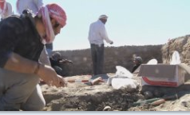 | Screenshot from film Digging Out by Four Corners Media, permission granted by email 16th Feb 2016
Music | for airport? | "Train Station Lobby Ambience with a PA Announcer, Belgrade, Serbia" by Tomlija (http://freemusicarchive.org/music/Tomlija/Walla_Walla_Walla/Walla_Walla_Walla_-_Tomlija_-_Train_Station_Lobby_Ambience_with_a_PA_Announcer_Belgrade_Serbia) | via Vimeo (CC Attribution)

Video clips of the reconstruction of Ancient Babylon are used here with kind permission of the Byzantium 1200 project and its owners, and remain copyrighted to them so cannot be used without permission. For more information about the Byzantium 1200 project please see http://kadingirra.com/

