
EPSRC Centre for Doctoral Training (CDT) in Molecular Sciences for Medicine (MoSMed): MoSMed2

Real-Time Cryo-Electron Microscopy to Investigate Enzyme Allostery

Newcastle University, Biosciences Institute

Supervisory Team | - Prof Wyatt Yue (Newcastle, lead)  - Dr Thomas McCorvie (Newcastle)  - Dr D. Sean Froese (Children’s Hospital Zurich)

Award Summary
100% Home fees covered and a minimum tax-free annual living allowance of £20,780 (2025/26 UKRI rate). An additional allowance will be provided to contribute towards consumables, equipment, and travel related to the project.

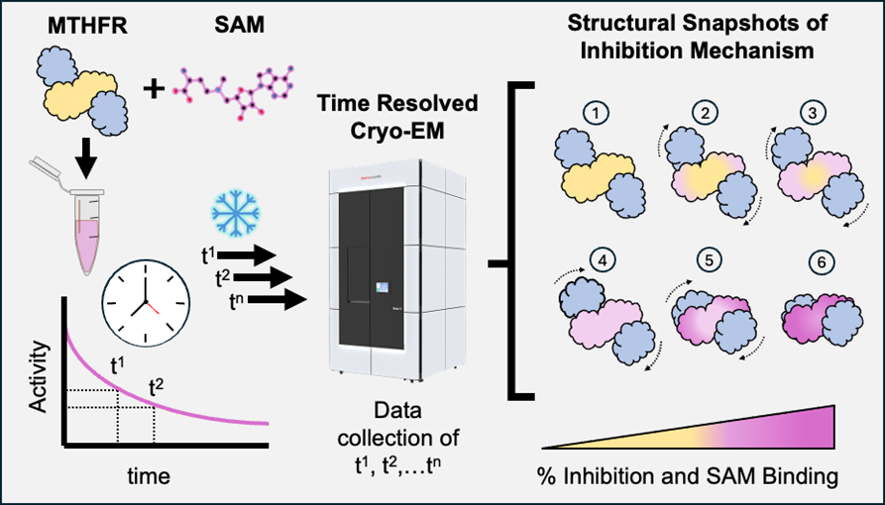
Project overview/context
Allosteric regulation of enzymes involves the binding of ligands at sites other than the active site, resulting in a structural change that alters the enzyme’s function. Recent technological advances in cryo-electron microscopy (cryo-EM) using time-resolved methods have allowed for the visualisation of multiple structural states of enzymes during allosteric regulation. This project combines time-resolved cryo-EM, biochemical and biophysical techniques to capture structural snapshots of the intermediate states involved in the allosteric regulation of methylenetetrahydrofolate reductase (MTHFR), a folate metabolising enzyme with implications in cancer and neurological diseases. This study opens up our understanding of this protein for novel medicine discovery.

Research Project
MTHFR is an essential folate metabolising enzyme that generates S-adenosyl-l-methionine (SAM), an important biomolecule for a myriad of cellular processes including epigenetic methylation. As such its activity is tightly regulated by the level of SAM to maintain the cell’s metabolic needs. MTHFR harbours a regulatory domain [1] that binds SAM, in order to inhibit the enzyme’s catalytic site through a long-distance allosteric mechanism [2].

The student will carry out cryo-EM imaging of human MTHFR titrated with SAM at different time points, to capture the multi-step structural transition between an inhibited state (with SAM) and active state (without SAM or with SAM analogue) of the enzyme. This will be complemented by enzymatic activity assays, biophysical binding assays, and structure guided mutagenesis to decipher the molecular mechanism of SAM-mediated inhibition.

MTHFR dysfunction is a key driver for cancer and neurological diseases. This project navigates the interface of cutting-edge structural biology, biochemical mechanism investigation, and novel target discovery [3].

Further reading
[1] Froese et al (2018) Structural basis of human 5,10-methylenetetrahydrofolate reductase (MTHFR) regulation by phosphorylation and S-adenosylmethionine inhibition. Nat Comm 9:2261
[2] Blomgren et al (2024) Dynamic inter-domain transformations mediate the allosteric regulation of human 5, 10-methylenetetrahydrofolate reductase. Nat Commun 15:3248
[3] Bezerra et al (2021) Identification of small molecule allosteric modulators of 5,10-methylenetetrahydrofolate reductase (MTHFR) by targeting its unique regulatory domain. Biochimie 183:100

Training & Skills
The student will be trained in cryo-EM sample preparation and high-end 3D-classfication and 3D-variability tools to process cryo-EM data, aimed at capturing multiple intermediate structures of MTHFR. Further support of the project comes from our external partner Dr Sean Froese (Children’s Hospital Zurich) with expertise in MTHFR cell biology. The student will also benefit from bespoke research and life skills training programme through alignment the Newcastle-Durham MosMed EPSRC Centre for Doctoral Training.

Further Information

Email wyatt.yue@newcastle.ac.uk
Visit https://www.staff.ncl.ac.uk/yuelab/
Follow us on: https://bsky.app/profile/wyattyue.bsky.social

Eligibility
Please see the MoSMed website for further details regarding academic eligibility.

The studentship covers fees at the Home rate (UK and EU applicants with pre-settled/settled status and meet the residency criteria). International applicants are welcome to apply but will be required to cover the difference between Home and International fees.

International applicants may require an ATAS (Academic Technology Approval Scheme) clearance certificate prior to obtaining their visa and to study on this programme.

How to Apply
You must apply through the University’s Apply to Newcastle Portal
Once registered select ‘Create a Postgraduate Application’.
Use ‘Course Search’ to identify your programme of study:
- search for the ‘Course Title’ using the programme code: 8420F
- Select ‘PhD Biosciences (full time)’ as the programme of study.
  - We welcome applicants who wish to undertake their studies part time. To do so, please instead select ‘PhD Biosciences (part time)’ as the programme of study and 8420P as the programme code.
You will then need to provide the following information in the ‘Further Details’ section:
- a ‘Personal Statement’ (this is a mandatory field) - upload a document or write a statement directly in to the application form. Please include the full title of the studentship, the studentship code (mos2_04), and how your interests/experience relate to the project.
  - the relevant studentship code (mos2_04) in the ‘Studentship/Partnership Reference’ field. You must include the relevant code for your application to be considered.
  - when prompted for how you are providing your research proposal - select ‘Write Proposal’. You should then type in the title of this project. You do not need to upload a research proposal.
In the ‘Supporting Documentation’ section please upload:
- An up to date CV.
Please upload all documents in PDF format.
You must submit one application per studentship, you cannot apply for multiple studentships on one application.

Equality, Diversity and Inclusion (EDI)
Within the MoSMed CDT we are committed to building a diverse community based on excellence and commitment. To that end, in our recruitment of Doctoral Researchers we welcome applications from outstanding candidates of all backgrounds regardless of ethnicity, disability, gender identity, sexual orientation and will consider all applications equally based on merit.

Should you have any queries regarding the MoSMed application process to Newcastle University please contact Craig Hinds, the MoSMed CDT Manager: mosmed.cdt@newcastle.ac.uk

