Identifying the Roma languages in Newcastle
Stage 1 (a local church)
I was given the contact details of 2 local translators – one Romanian (Stefania) and one (Roma herself - Eva) Czech and Slovak, who regularly work with local people and who are therefore very trusted. Both are using the leaflets to try to locate pupils attending local Primary schools and to identify the Roma dialect. Then one cold Monday morning just before Christmas, I attended an open support event at an old Methodist church in the centre of Newcastle, which happens every Monday, and which always attracts lots of Roma families, together with Stefania and Eva. Eva was completing her usual service to the families and asked them questions about their home languages during those meetings as an aside. Stefania spent the time working directly with me so that I could talk in person with some of the families.
It was absolutely fascinating. One group of Roma women, some quite elderly, were delighted to talk with me about their own heritage and language and in the end they also told me about some of the other Roma groups in attendance. This was because one group in particular refused to acknowledge their Roma heritage and one man (who I recognised as a Big Issue seller on one Newcastle street) said he was quite insulted that we would suggest such a thing. I can say with certainly however, that at this event there was no contact between this group and other families.
So with a little help from one grandmother, a group of lively women and a group of young Romanian Roma men who were also more than happy to talk about their heritage, this is what I found out:
- The first group with the chatty ladies and grandmother were Ursari – musicians traditionally, and the language they identified belonging to this group they wrote as ‘ursareasca’, but the young men later told me that was just another way to say Ursari.
- The group from which the man did not want to identify as Roma, were Platosi (copper/tim makers of pots and roofs). The women had very long hair which is how the other group said they were often identified.
- Another group of mothers also happy to talk to me were Lingurari with a language called lingurāreasca (traditionally makers of pots and spoons).
- Another group were identified as Cāldarari (makers of big pots).
- Another language mentioned was Romonizoti – but I’m not sure whether that is the Romanian word for Roma – Nicu?
- Some of these names can be found in the databases I found online http://romani.humanities.manchester.ac.uk/rms/browse
http://romani.uni-graz.at/romlex/whatisromani.xml
- I was told repeatedly by several groups that the children were better at Romanian than the Roma languages. So this really needs confirming so that we can decide which languages are worth pursuing for translation?
Meanwhile Eva collected the following information about Primary aged children, many of whom seem to have older siblings also at school. They were happy for us to know their child’s name.

school | Child’s name | language
WH | Gabriela Kasperova | Romanes – Czech Roma
Atkinson Road | XXXXX (not required as the school isn’t in the partnership) | Czech
WH | David and Richard Kroka | Romanes –Czech Roma
WH | Menissa Gunarova; Roman Kurej Gunar; Chanel Gunarova | Czech

We had lots more to do but this was a fascinating start!
In between stage 1 and stage 2, the Arthur’s Hill schools employed Zaneta who is Eve’s sister, as a community worker and translator.
Stage 2: at school
Identifying the Roma languages – stage 1 (Arthur’s Hill Federation Primary school)
10th June 2015 Westgate Hill School – notes from meeting with Slovak/Czech Roma families
10 families (mostly mums, two dads, two children), Zaneta Karchnakova, Heather Smith, Lydia Wysocki
With outstanding translation from Zaneta, Heather introduced the project (to help children learn better together) and the purpose of today’s meeting (to meet some of the parents and understand which languages they speak at home and in what combinations).
There was a hesitant start to understanding which languages are spoken at home by which families, including:
- fluent Roma, not much Slovak
- mostly Slovak, a few words of Roma (Slovak and Roma mixed together)
- mostly Slovak, a few words of Roma learned from other children (not from parents)
- Slovak; understand some Roma but not spoken at home
- mixture of Slovak and Roma
- mostly Roma
- mixture of Czech, Slovak and Roma.
Most parents were adamant that there was one variety of Roma language – they were sceptical when Heather told them that there are many dialects of Roma, so showing the long list of Roma dialects that have been identified and named through academic research was a helpful social activity to show the complexity of working with these languages. Parents who had initially said they did not speak Roma at home gradually said that they did speak some Roma, and how this was mixed with the Slovak they spoke.
Romungro dialect was included in the academic research list – some parents made it clear that this is not considered a positive term for the language, even though the list contained self-designated names for Roma dialects. One father made the point that translation work should be paid work.
It was only when identifying Roma words to translate the list of English words (bread, water, sun, mother, door, shoe, apple, box, window, cup, grass, house, tree) that most parents realised that there are different Roma dialects. Some words had slightly different versions (bread = maro, maRno, maNdro; maNdro was given as a word used in a neighbouring village but not used by these children), and other words had more obviously different versions (mother = mamO, dAi, miri dAi, mUri dAi, mUri mamO; apple = paboi, mena, burtko). Some words were the same as Hindi words (water = pani; cup = biri) and some parents were aware of this.
Sharing some other key words was also socially important:
English | Slovak | Roma
hello | dobry den | lacho zhiveS
thank you | yakuyum | p/balikerao
shush! | tshiho!

p/b sounds and g/k sounds were sometimes hard to distinguish
word stress was important
1st Roma languages survey outcome
Transliterations of words from families in Arthur’s Hill Federation
Slovak-Roma families, 10th June 2015
Word in English | Word in East Slovak Roma (we think) | Word in Kalderash/Kalderaš/Căldărari (we think)*
bread | maro | marno
water | pani | paji
sun | kham | kham
mother | mamo/miridaj | mamo/muridej
door | vudar | vudar
shoe | kamašli | [not recorded]
apple | phabaj | phabaj
box | škatula/krabice | [not recorded]
window | oblaka | fejastra
cup | poharis | čejza
grass | čar/trava | čar/trava
house | kher | kher
tree | stromos | kopači

* NOTE this has subsequently proven to be incorrect. The language is mostly likely Czech Vlach

Stage 3: 2nd meeting at school in the Women’s Group meeting
We next held a meeting at the school with the network of mothers set up by Zaneta in October 2015, the results of which are below:
Notes from Westgate Hill Eastern European Women’s Group meeting
Thursday 21st October 2015, 9.30-11am

Six mums and one two year old boy, Zaneta, Heather and Lydia
None of these six mums were at the previous languages session led by Heather and Zaneta, but had heard about the project from Zaneta and from other parents; the wife of one of the parents in the first language session was at this session.
First Heather (with Zaneta’s translation) gave an overview of the ROMtels technology, showing a still from Patrick’s video of the test run at the September transnational partner meeting and Hollie’s screenshots of the tools and apps. The mums were very positive about the technology, and interested in the Great Fire of Tyneside content as well.
We had initially planned to use the Manchester language database http://romani.humanities.manchester.ac.uk/rms/ to check that the languages we had tentatively identified were indeed Kaldarari and East Slovak Roma. This plan had to change as different parents were at this session, so Heather used the same database to check specific words. Most of the mums spoke what we think is East Slovak Roma, one spoke no Roma languages, one (the wife of a father in the first language session) spoke a language close to Kalderash but with some slight differences and some bigger differences in specific words.

After this short session we joined the mums in the food technology room, where a local caterer was leading an international cooking demonstration, making falafel. With Zaneta’s translation Heather spoke with the mums and introduced the idea that some parents would be paid to do translation work for short animated videos as part of the project. This will need to take place after half term, either at the school or at the University.
English | East Slovak Roma from website | As spoken | Kalderash from website | As spoken | Kalderash dictionary
Boy | chavo | √ | gloata | chavoro | shavorro
Dog | O rikono | rikono | zukel | √ | zhukel
Skin | cipa | √ | morki | kanye | unidentified
Arm | musy | √ | braco | vast | unidientified
Foot | O pindro | √ | E labar punreski | punro | punrro
Stomach | zaludkos | √ (inside, guts) | stomako | per | purr
Today | adadjives | √ | Ag’es | √
tomorrow | tajsa | √ | tehara | √

The table reveals all words correct for East Slovak and most for kalderash (using the Manchester website and the English Kalderash dictionary – a mix of both sources).
From this event Marta came forward as someone who would be interested in helping us with the translations. Zaneta also contacted Laco’s wife to ask as she had shown interest in the first meeting. Later it transpired that Laco was more interested and keen to participate.

We then started the process of what we are now referring to ‘translanguation’ (translanguaged translation).
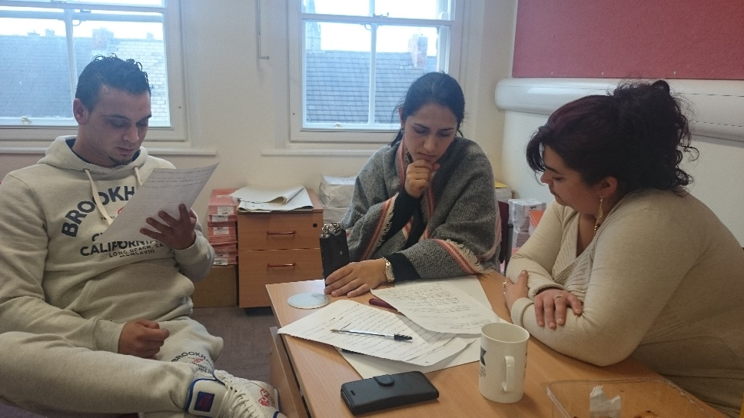
Our first translation sessions at the school started by watching the English language animations for each character in each Enquiry. Then Zaneta (the community and language worker in Newcastle) translated each character’s script from English to Czech (very close to Slovak). After that, Zaneta worked with the parents to translate from Czech into a translanguaged form of East Slovak Roma and Slovak. We gave the parents one simple instruction – say what you think your children would best understand, whether this means combining languages or not.
Since then, our process has become more efficient and Zaneta was able to translate the scripts from English to Czech in advance of each session. This meant that Laco and Marta (the parents) could focus on moving from Czech to Slovak and East Slovak Roma. It also meant that when the parents were working on separate character’s scripts, Zaneta had already read both full scripts so could more easily swap between the two (not take everything one sentence at a time).
The parents then recorded each sentence, or group of sentences, as an .MP3 file using an audio recorder. The parents also checked each other’s translation, to spot errors or agree changes. They made some of these changes to their written translanguaged scripts, and some changes when they read each sentence aloud as a practice prior to recording it.
The parents did not simply translate into East Slovak Roma. They took each unit of meaning and decided how to capture this in a combination of Roma and Slovak to make it the most accessible to the children, drawing on Slovak, for example, if children were more likely to recognise less commonly used (or non-existent) East Slovak Roma words. They did this following a clear steer from us, when we asked, ‘how would you say this at home’?
We are calling this process translanguation to capture both elements: translation and translanguaging. We are yet to determine the level of linguistic code-switching involved, and whether the grammar is predominantly one language or another, or is mixed. This will be an exciting research project in itself!

Stage 4: Czech families in school
June/July 2016 we met a small group of Czech families across the 2 schools to identify their languages. Unfortunately we were unable to access the internet to check against the database, so we took them to the enquiry space instead and they watched one of the videos. They said they were all able to understand the characters’ speech in East Slovak Roma and because there are far fewer Czech pupils in the schools, we decided not to translate any of the enquiries into a Czech dialect.

Stage 5: identifying the Romanian Roma languages in school
July 2016 we met with a handful of Romanian families at the school over 2 meetings and we concluded, using the database, that the families who attended spoke Ursari and this was a language name they identified with. Mr Nemeth also attended the first of these meetings and we concluded that his language was actually Czech Vlach. At this meeting they also referred to Platosi and Tanderen (Bucharest) speakers.
After the 2nd meeting, one of the mothers, Coranitta Baiculescu, rang the school to leave a message for me to say that she and her brother, who both speak good English as well as Urasari and Romanian, would be interested in doing the translations and recordings.
The results of the Newcastle team and the methods employed were shared across the partnership and each partner then also employed the Manchester database to work with parents. Please see the video of this process taken in Sete.
So, to date we have the following evidence of Roma languages spoken in Newcastle, Helsinki region, Oradea and Montpellier.

Languages identified in ROMtels as of June 2016
 | Slovak Republic | Czech Republic | Romania
Newcastle | 1. East Slovak Romani | Not identified BUT can understand East Slovak Romani | Ursari
 | 2. Czeck Vlax
Sete near Montpellier, France |  |  | Ursari
Tinca, Romania |  |  | Korturare
Helsinki region, Finland |  |  | Ursari

