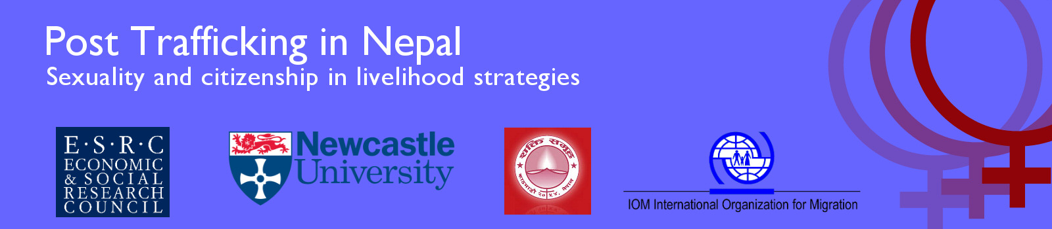
Bulletin 5 (February 2012)

Professor Diane Richardson, Principal Investigator, Newcastle University, UK
Professor Nina Laurie, Co-Applicant, Newcastle University, UK
Dr Janet Townsend, Co-Applicant Newcastle University, UK
Dr Meena Poudel, Research Associate Newcastle University and IOM, Nepal

This large ESRC project runs from November 2009 to April 2012 and is collaboration between Newcastle University, the Non Government Organisation ‘Shakti Samuha’ and the International Organisation for Migration (IOM) Mission in Nepal. It aims to explore the situation of returnee trafficked women. To date there has been little research on neither post trafficking livelihoods nor how the issues raised by trafficking intersect with development agendas. A key aspect of this research is to gain knowledge that is grounded in the actual experiences of the Nepalese trafficked returnee women themselves. We are interested in how returnee livelihoods intersect with sexuality and citizenship.

Final Phase of Fieldwork Completed and Research Seminar Held in Kathmandu

Professor Laurie and Professor Richardson joined Dr. Poudel in Nepal during October and November to carry out the final phase of fieldwork interviewing stakeholders and members of Shakti Samuha, the partner organisation, a total of twenty interviews in all. A highly successful research seminar was held in on Kathmandu on November 4th to disseminate preliminary findings from the analysis of the interviews conducted with returnee trafficked women. The seminar ‘Making Livelihoods Post Trafficking: Sexuality, Citizenship and Stigma’ was opened by the Minister for Women, Children and Social Welfare and attracted more than 120 participants, including several members of the Constituent Assembly and senior policy makers. Shakti Samuha, our partner organisation, gave a presentation based on their involvement in the Research Training aspect of the project entitled ‘Trafficked Survivor to Social Researcher: A Reflection of the Journey’. Later in November they took part in the third research training session on Research Methodology. The fourth session held in January was on Formulating a Research Proposal.

The Conference Report and the working paper ‘Sexual Trafficking, Poverty, Marginalization and Citizenship in Nepal’ are available for download from our website www.posttraffickingnepal.co.uk. The research findings and seminar were also featured in the Kathmandu Post see:

http://www.ekantipur.com/the-kathmandu-post/2011/10/30/metro/trafficked-women-returnees-on-a-razor-edge/227657.html.

<http://www.ekantipur.com/2011/11/10/capital/trafficked-women-returnees-woes-of-victims-lying-in-neglect/343547.html>

We fed back on fieldwork and dissemination to the Advisory group in a teleconference meeting in December 2011.

Invitation to speak at the Asia Research Institute, National University of Singapore

In October Professor Laurie and Professor Richardson visited the National University of Singapore where they presented an invited paper 'Crossing back over the open border: geographies of post trafficking citizenship in Nepal' at the Crossing Borders, Traversing Boundaries conference organised by the Asia Research Institute. A copy of this working paper is available for download from our website www.posttraffickingnepal.co.uk. During their visit Professors Laurie and Richardson also gave a presentation on the project to the Department of Geography and Migration Research Cluster.

Other contributions include:

- Presentation on the preliminary findings from the research to the Anti-Trafficking Inter-Agency Co-ordinating Group Meeting November 10th 2011 at The Asia Foundation, Kathmandu, Nepal.
- Briefings to European Union Members of parliament on the research findings and the implications of Nepal’s new constitution for returnee trafficked women’s citizenship rights.
- Conceptual input to DFID anti-trafficking regional programme.
- Input into VSO country strategic planning (gender and migration perspectives) at the Gender Tools and Strategy Planning Workshop, where our research findings were shared.
- During February 2012 Dr. Poudel visited Turkmenistan where she delivered a week long training course on ‘Gender Mainstreaming and Counter-Trafficking in Persons’ and ‘Victims of Trafficking and Prevention of Stigma and Discrimination in the Communities’ and shared findings from the project to more than 35 participants representing a range of anti trafficking stakeholders: NGOs, counsellors, shelter managers, lawyers, hotline service providers, psychologists and IOM staff members from Turkmenistan and Kyrgyzstan.

We will be presenting at the following upcoming conferences

- Non Belonging and Claiming Citizenship: Anti-trafficking activism and Professionalisation in Nepal, American Association of Geographers (AAG) Annual Conference, February 23rd-28th 2012, New York, US.
- UK policy briefing and launch of our User Summary on April 18th in London, hosted by DFID, with Amnesty International and the Foreign and Commonwealth Office (FCO) as discussants
- Whose Agenda? Securitisation and Prosecution in Anti-trafficking: Some Lessons from Nepal, Institute of British Geographers (IBG) Gender, Justice and Security stream, July 2012, Edinburgh University, UK.

For more information visit our web-site:

www.posttraffickingnepal.co.uk
or find us on Facebook

https://www.facebook.com/posttraffickingnepal

or e-mail:

Nina.Laurie@ncl.ac.uk
Meena.Poudel@ncl.ac.uk or Mpoudel@iom.int
Diane.Richardson@ncl.ac.uk
Janet.Townsend@ncl.ac.uk

