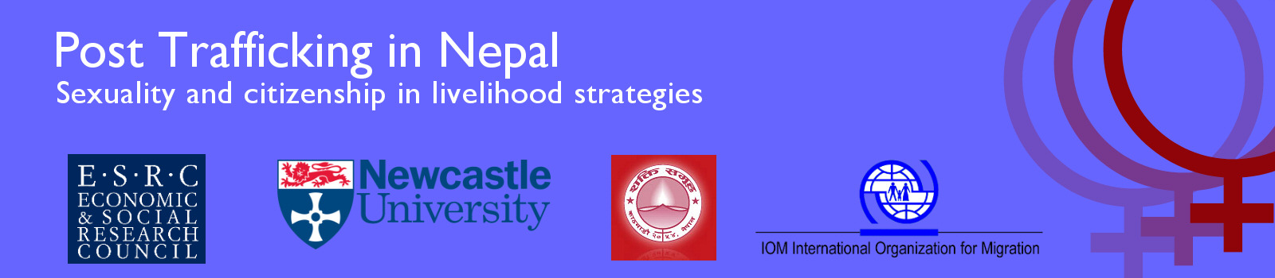

Bulletin 4 (August 2011)

Professor Diane Richardson, Principal Investigator, Newcastle University, UK
Professor Nina Laurie, Co-Applicant, Newcastle University, UK
Dr Janet Townsend, Co-Applicant Newcastle University, UK
Dr Meena Poudel, Research Associate Newcastle University and IOM, Nepal

This large ESRC project runs from November 2009 to April 2012 and is a collaboration between Newcastle University, the Non Government Organisation ‘Shakti Samuha’ and the International Organisation for Migration (IOM) Mission in Nepal. It aims to explore the situation of returnee trafficked women. To date there has been little research on post trafficking livelihoods nor how the issues raised by trafficking intersect with development agendas. A key aspect of this research is to gain knowledge that is grounded in the actual experiences of the Nepalese trafficked returnee women themselves. We are interested in how returnee livelihoods intersect with sexuality and citizenship.

Emergent findings

Charimaya Tamang (Anu), Shakti Samuha's founding member and current board member, was awarded the “2011 Hero Acting to End Modern-Day Slavery Award" for her contribution to anti-trafficking work in Nepal.
Over a period of three months, starting in May 2011, the team analysed transcripts of thirty seven interviews conducted with returnee trafficked women. These were then collectively coded with core themes emerging around issues such as marriage, the effects of stigma and the processes through which a woman’s trafficked identity becomes hidden or disclosed. When reading across the whole sample it was interesting to see new findings emerge that had not been apparent in the preliminary analysis of the pilot interviews. In particular there were striking similarities in women’s definitions of trafficking and statements about the homogenising experience of rejection for all women post trafficking.
In July a round table workshop provided a wider forum to debate the project’s on-going findings. This event brought together policy-makers, academics and activists from the UK, Canada and Bangladesh in the fields of development, South Asia Studies and trafficking. It coincided with a face to face meeting of the project’s Advisory Panel where the findings were discussed in more depth and the dissemination strategy reviewed to ensure maximum impact from the research for different audiences.

Fieldwork

The project team has finalised two schedules for interviews to be conducted in the last phase of fieldwork, commencing October 2011. These will target the Shakti Samuha leadership team (nine members of the newly elected executive committee) and other stakeholders (NGOs representing the broader areas of anti-trafficking, women’s rights and development and eleven participants representing policy makers including relevant members of the Constituent Assembly and donor representatives).

The development of the interview schedules benefitted greatly from project Advisory Panel members’ input when they met in Newcastle to discuss future fieldwork and dissemination in the lead up to a final workshop in Kathmandu in the autumn and a policy workshop in London, in spring 2012.

Publication

A Book by Meena Poudel based on her PhD (awarded by Newcastle University in 2009) has been published by Lambert Academic Publishing entitled: “Dealing with Hidden Issues: Social Rejection Experienced by Trafficked Women in Nepal” (2011).

We will be presenting at the following conferences during autumn 2011

- Crossing Back Over the Open Border: Geographies of Post Trafficking Citizenship in Nepal, Crossing Borders, Traversing Boundaries: Bridging the Gap between International and Internal Migration Research and Theory, National University of Singapore.
- Geographies of Livelihoods and Passing Among Returnee Sexually Trafficked Women in Nepal, annual conference of the Institute of British Geographers with the Royal Geographical Society, London.

We have contributed to the following during 2011 to date

- Briefings to UK Members of Parliament on the implications of Nepal’s proposed new constitution on returnee trafficked women’s citizenship rights.
- A policy presentation focusing on citizenship, human rights and livelihood to decision makers in the research, campaigns and gender departments of Oxfam GB.
- Conceptual input to a new large DfID anti-trafficking regional project collaborating with the DfID representative on the project’s Advisory Panel.
- Conceptual input as a member of an expert team that advises the government of Nepal on revising the National Action Plan to combat trafficking.
- Interdisciplinary academic debates at learned society conferences including the British Society of Criminologists, The Development Studies Association, the Britain-Nepal Academic Council, The British Sociological Association, The American Association of Geographers and specialist international workshops including ‘Performing Geopolitics’ (Durham University) and ‘Gender, Sexuality and Political Economy’ (Manchester Metropolitan University).
- Student learning with a paper at a student-led annual national development conference entitled: “Inequality: challenging an assumed reality”.

For more information visit our web-site:

www.posttraffickingnepal.co.uk,

or e-mail:
Nina.Laurie@ncl.ac.uk
Meena.Poudel@ncl.ac.uk or Mpoudel@iom.int
Diane.Richardson@ncl.ac.uk
Janet.Townsend@ncl.ac.uk

