DMPonline V3 Guide
DMPonline tool was authored by the UK's Digital Curation Centre (www.dcc.ac.uk). This user guide provides local context for v3 of the tool and is subject to any future changes of the DMPonline tool. Please check the ‘News’ tab of the DMPonline website for future updates (v4 is expected in Summer 2013).
DMP Online is a research data management tool currently being considered by Newcastle University for possible implementation. Any reference to using the DMP Online tool or aspects of the system is purely for testing and evaluation purposes.
For further help or additional information, please see: http://research.ncl.ac.uk/rdm/tools/dmponline/

Table of Contents
1 Introduction 3
2 Sign in with your Shibboleth institutional credentials 4
3 Creating a new plan 5
4 Managing a data management plan 8
4.1 Editing project details 8
4.2 Project phases 9
4.3 Sharing your plan 9
4.4 My plans – filling in a plan 13
4.5 Exporting a plan 17
4.6 Locking, duplicating and deleting a plan 19

Table of Figures
Figure 1: DMP Online Home Site 3
Figure 3 If signing up using your institution credentials, you will need to search your institution 4
Figure 4 Enter your Newcastle University credentials 4
Figure 5: enter project details 5
Figure 6: Template selection 6
Figure 7: Newcastle University template 6
Figure 8: ESRC template showing only the application phase 7
Figure 9: History funding template showing the application and funded phase 7
Figure 10: Project details can be amended, the plan can be shared with others, project phases templates can be completed, plans can be exported, locked, duplicated and deleted from this window 8
Figure 11: Edit Project Details allows you to go back and amend the project details you first specified 8
Figure 12: Application and Funded phases of a plan template, each phases contains a different set of questions 9
Figure 13: A project can have several funders, thus several templates can be used in plan 9
Figure 14: Share button 9
Figure 15: Project sharing site – Single Funder 10
Figure 16: Project Sharing Site – Single Funder – Adding an e-mail address 10
Figure 17: Project Sharing Site – Multiple Funders – Simple Sharing 11
Figure 18: Project Sharing Site – Multiple Funders – Advanced Sharing 11
Figure 19: A shared plan with only read rights, at the top of the project details section a note will be given informing the user of the rights he/she has for that specific shared plan. Notice buttons in grey are buttons not accessible in a plan with only read rig 12
Figure 20 Project sharing section, now showing the users you are sharing with 13
Figure 21: My Plans button 13
Figure 22: My Plans section, here you can see all your existing plans, review or export them or even create a new plan 13
Figure 23: Edit Plan Button 14
Figure 24: To edit a plan you need to click the project phase you want to work with 14
Figure 25: A plan template showing its different sections and utilities 14
Figure 26: At the bottom of each section you will find the Save Responses button, click on it to save any changes to your plan 15
Figure 27: Application phase showing progress on its completion 16
Figure 28: Information button 16
Figure 29: Once you click on the Information button, you will be offered help about the question you are trying to complete, a pop up window will appear 16
Figure 30: Add question page, from here you can add question to the template you are working with 17
Figure 31: Export button 17
Figure 32 Project phase selection for exporting 17
Figure 33 Combined output option 17
Figure 34 Here you can select what to export 18
Figure 35 Change the order of the sections or dismiss sections 18
Figure 36: Export format options and page layout options 18
Figure 37: Lock, Duplicate and Delete buttons 19

Introduction
“Funding bodies increasingly require their grant-holders to produce and maintain Data Management Plans (DMPs), both at the bid-preparation stage and after funding has been secured. DMP Online has been developed by the Digital Curation Centre to enable you to build and edit DMPs according to the requirements stipulated by the major UK funders”.
The DMP Online is accessible through this link https://dmponline.dcc.ac.uk/, Figure 1. The website comprises of eight sections which are accessible through the menu bar. The sections are: Front Page, About, Instructions, Future Developments, News, Documents, My Plans and Shared Plans.
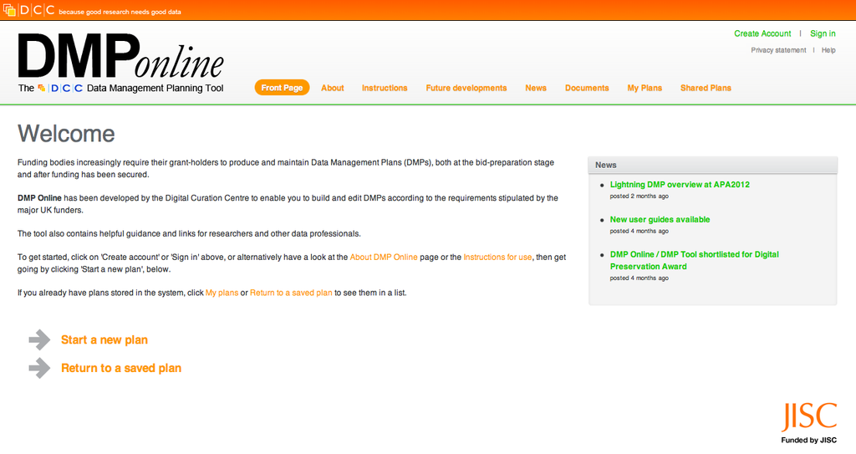Figure 1: DMP Online Home Site
- Front Page: includes a brief welcome from the DCC and News about the platform, if you already have an account, you can directly start a new plan or return to a saved plan from the Front Page
- About: explains the concept behind the DMP Online
- Instructions: a quick description of how to use the website.
- Future Plans: describes underway, planned and possible development plans contemplated for the DMP Online website
- News: contains any information the DMP Online wants to disseminate, from user guides to news concerning the launching of new features of the website
- Documents: users can download any DMP online related documents
- My Plans: only accessible once the user has logged in. This section contains all the DMPs a user has created, and from this section users can either review or export any plan
- Shared Plans: only accessible once the user has logged in. This section contains plans that have been shared with other users. Again, this section allows user to either review or export any plan

Sign in with your Shibboleth institutional credentials
The first step to gaining access to the all the functionalities of the DMP Online is to create an account:
- Go to the DMP Online website: https://dmponline.dcc.ac.uk/
- Sign in using your institution credentials. To do so, Click on Sign in
  - A new window will appear. In the text box provided you will need to type in the name of your institution (Newcastle University in this case). You can either use the search feature or select the institution from the drop down menu. Once you have done this , click continue( Figure 4)
Figure 3 If signing up using your institution credentials, you will need to search your institution
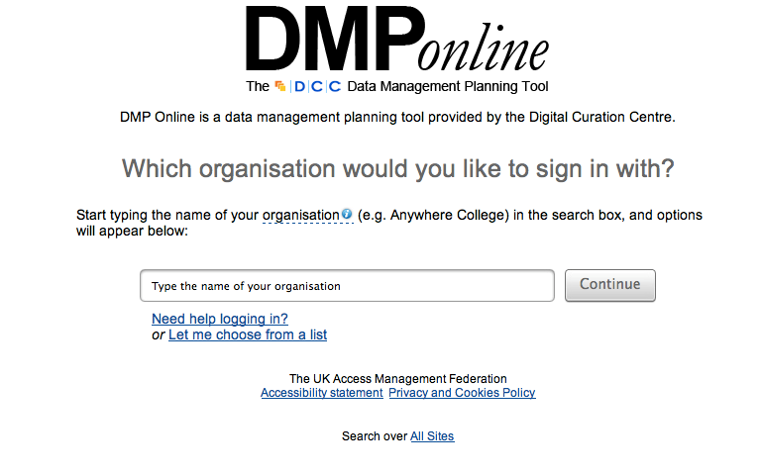
  - You will now need to enter your institutional Login ID and Password, Figure 5
Figure 4 Enter your Newcastle University credentials
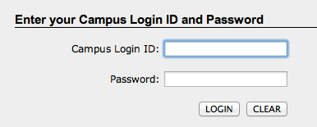

Creating a new plan
Now that you have a user account, you can start creating Data Management Plans.
- Sign in to your account
- From the site’s Front Page select Start a New Plan
- First you will need to provide the project details. Mandatory fields are marked with a star *
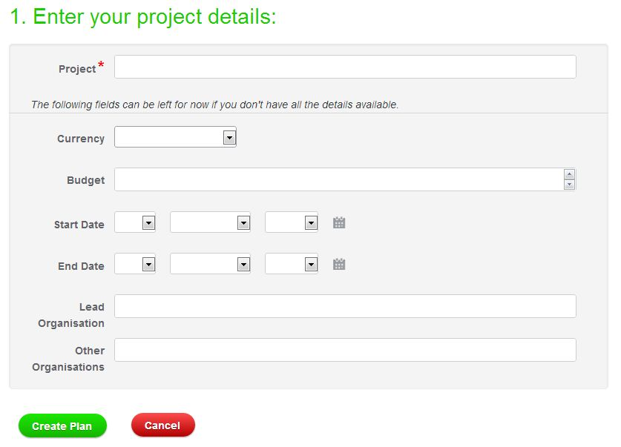
Figure 5: enter project details
- You will need to choose a template or templates for the funders and organisations involved in your project, see Figure 7. Choosing a template is mandatory; otherwise you will not be able to proceed with the creation of the plan.
- Templates are provided for a variety of funders and organisations such as: RCUK Research Councils templates, Institutional templates, US funders templates, etc. The Newcastle University template is located in the Institutional templates group. If you cannot find your funder’s template, you can use the Newcastle University Template, see Figure 7
- When creating new plans, try to create them using the template that corresponds to your funders and/or organisations
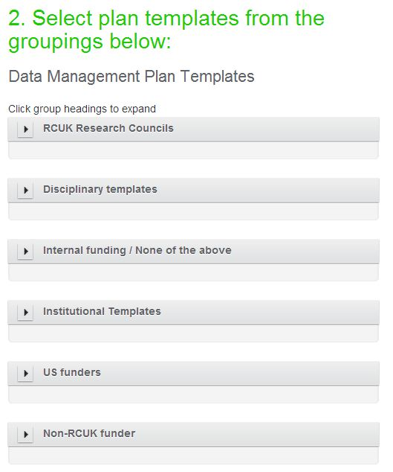  Figure 6: Template selection | 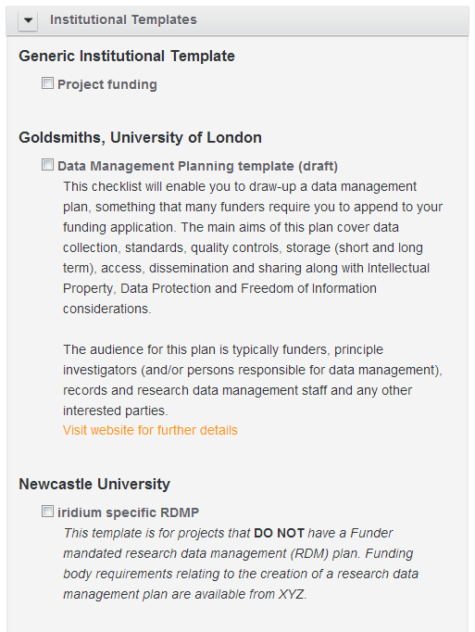  Figure 7: Newcastle University template
- Click Create Plan to save your project’s information
- Finally, you are able to manage and edit your plan. Depending on the funder, some templates may have one phase as default (Application phase), see Figure 9. Other templates may have two phases as default (one for the Application phase and another for the project-live phase or Funded phase), see Figure 10. The number of phases you are presented with will depend on funders’ requirements, and do templates can change with time as funders’ requirements change. Each template and phase has specific questions and guidance.
- Note: if you are completing the Newcastle University template there is only one template.
If you are using templates from different funders in the same plan, the information you will add in one template will be copied to the other template/s in the corresponding section. Note that the section and question numbers vary across different funders templates. This feature of the DMP Online allows you to populate multiple plans at the same time.
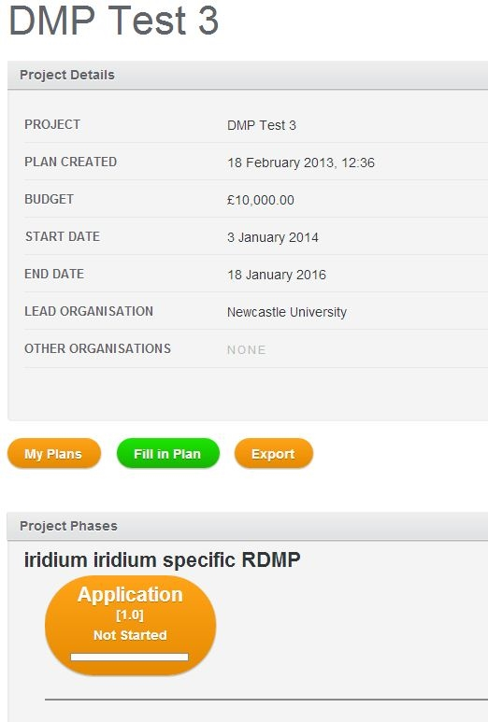  Figure 8: ESRC template showing only the application phase | 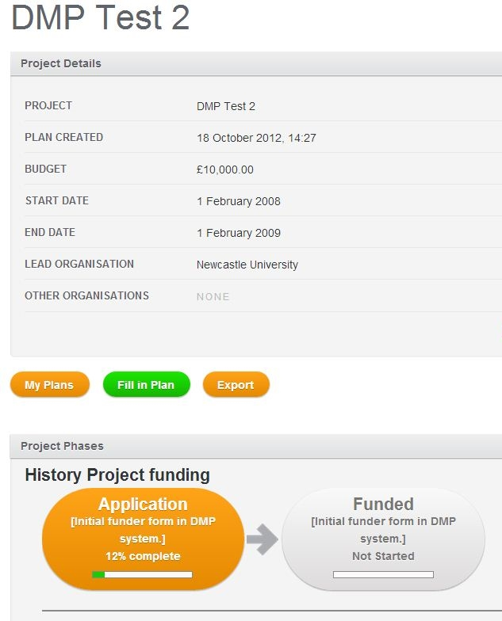  Figure 9: History funding template showing the application and funded phase

Managing a data management plan
Once you have created a plan (as described in the Creating a new plan section), you will be given the following window.
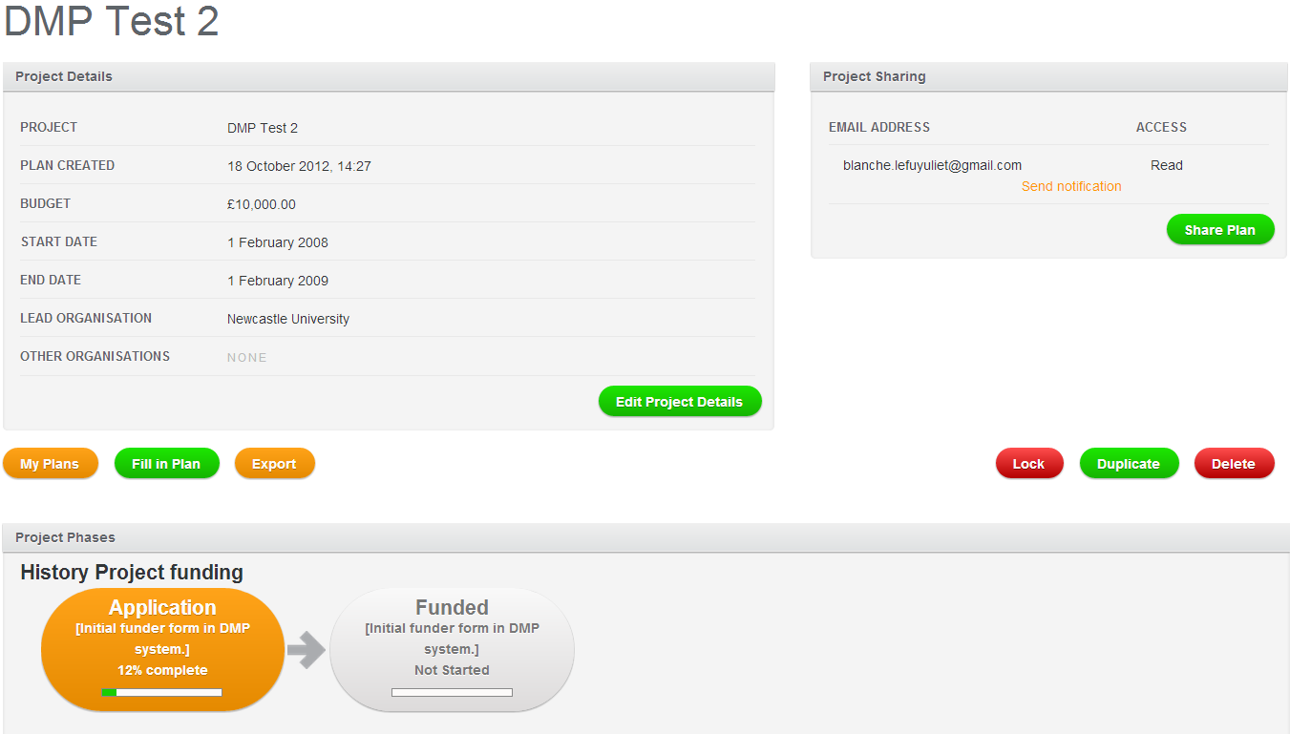

Figure 10: Project details can be amended, the plan can be shared with others, project phases templates can be completed, plans can be exported, locked, duplicated and deleted from this window

Editing project details
If you click on the Edit Project Details button you will be able to change the project details (currency, budget, start date, end date, etc.). You won’t be able to change or delete the project template that you chose previously but you will be able to add more templates from other funders and organisations if you wish.
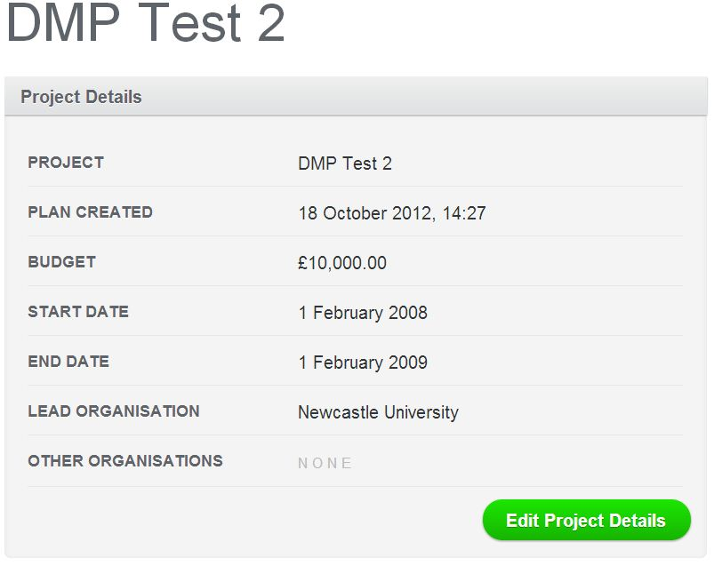
Figure 11: Edit Project Details allows you to go back and amend the project details you first specified

Project phases
This section shows the phases that your project has; this will depend on funder’s requirements. The Application phase is used at the bid-preparation stage. The Funded phase is used after funding has been secured, see Figure 13
If the project that you are working with involves several funders and you have selected several templates when creating your plan, then you will see these as well in the Phases section, Figure 14. It is important to note that you will have to complete each template individually, however, when there is an overlap of information requested through the questions of each template, and then the answers you provide for one template will be transferred to the other templates where possible. It is in this section where you will have the opportunity to check on the progress of the completion of each template.
Figure 12: Application and Funded phases of a plan template, each phases contains a different set of questions | Figure 13: A project can have several funders, thus several templates can be used in plan
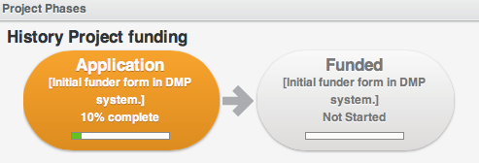 | 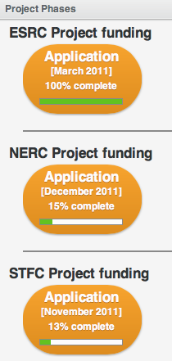

Sharing your plan
If you want to share the plan that you are working with, then you can do so by clicking on the Share Plan button, see Figure 15. This will take you to the Project Sharing site.
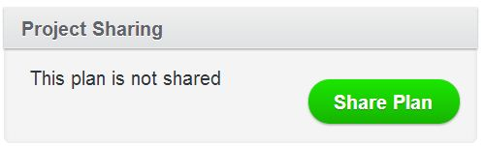
Figure 14: Share button
To share a project plan you will need to input another user’s e-mail. Later, you will be able to send a notification to the person that you are sharing with. The DMP online system does not automatically send the email. You will need to save the email address and return to the main plan screen and select send notification. When sharing a plan, you can provide either write or read rights. Write or read rights can be changed at any time by the creator/owner of the plan.
If the project you that want to share has only one funder (only one template with either 1 or 2 phases), once you click on the Share Plan button, you will be taken to the Project Sharing site, Figure 16. You will need to click on the + symbol to start adding the email addresses of users you want to share with. It is at this point when you can provide read or write rights, see Figure 17. If you want to stop sharing you plan with any user, you will need to click on the – symbol.
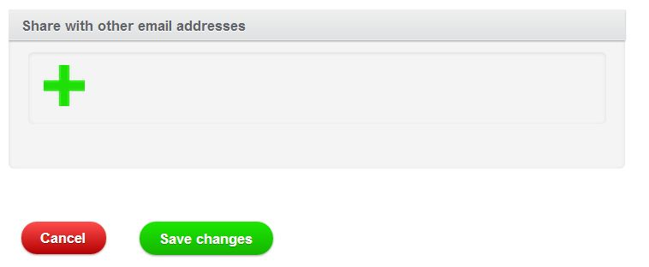
Figure 15: Project sharing site – Single Funder
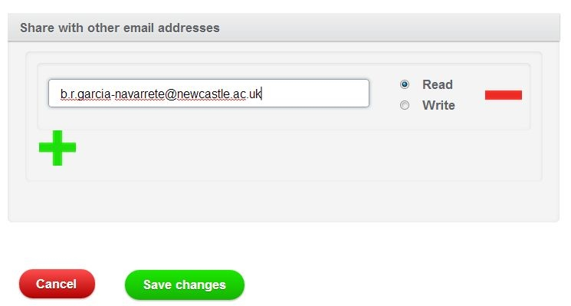
Figure 16: Project Sharing Site – Single Funder – Adding an e-mail address
If the project that you want to share has more than one funder (you will have different templates on the main plan site, see Figure 14), then the Project Sharing site will look different from what was described above. Instead, you will have 2 buttons at the top of the site. The Simple button will share all of the funder templates in the plan with the same rights (i.e. write or read), see Figure 18.
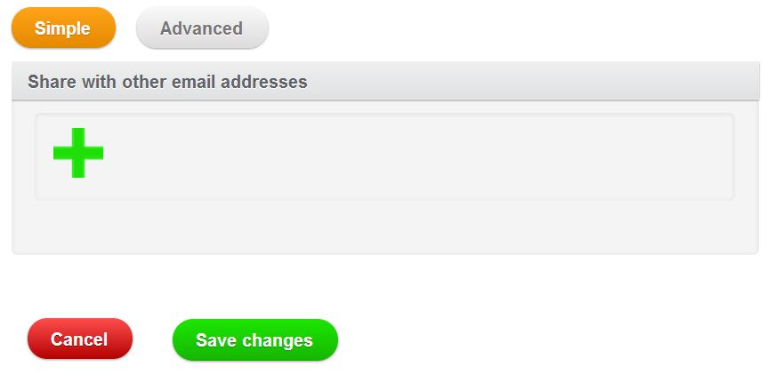
Figure 17: Project Sharing Site – Multiple Funders – Simple Sharing
The Advanced button allows the individual funder templates within the plan to be either write or read rights for different users. You can share one specific template with one user, and another template (from another Funder) with another user, and provide different rights to each of them. As mentioned above the write or read rights in an advance share can be amended at any time. When sharing, it is important for you to decide which mode are you going to use, either Simple or Advanced. For instance, if initially you were sharing in Advanced mode, and then you decided to share you plan with another user in Simple mode, then all the settings you had specified in the Advanced mode would be removed, and the email addresses you input in Simple mode will get transferred to the Advanced sharing site. The same applies if you were sharing in Simple mode and you decided to share in Advanced mode, the settings you had in Simple mode would be removed.
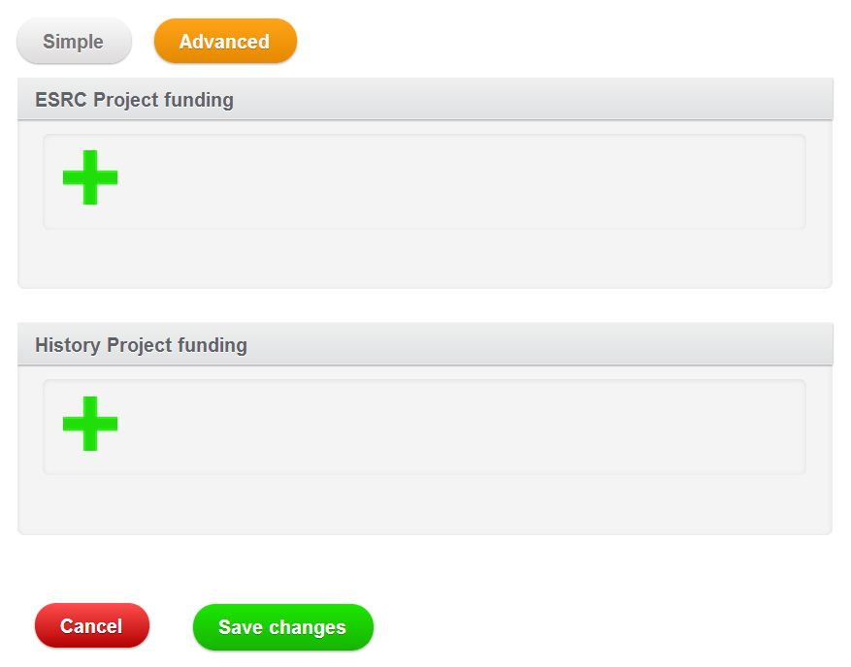
Figure 18: Project Sharing Site – Multiple Funders – Advanced Sharing
The type of rights that you provide is really important in terms of the future management of the specific data management plan that you are sharing. If you provide write rights to another user, then every time that user makes any changes to the plan, the plan will change immediately. No notification will be given to any of the other users that the plan is shared with. For this reason, it is important to agree with other users on the usage of the project plan and on the notification method to use.
If you provide only read rights to another user, then the user that you are sharing with won’t be able to make any changes to the plan, a red notification will appear at the top of the Project Details section as seen in Figure 20. The user with read rights only will not be able to have access to any information in the template besides the general project details.
The only way for that user to have access to the information would be if this user decides to export the plan (more information about exporting plans will be provided later in this document) or if this user decides to duplicate the shared plan (more information about duplicating plans will be provided later in this document). If the user decides to duplicate the plan, then this user will be making a copy of the plan you shared with them and it will not have any relation with the plan that you originally shared. This means that if you decide to make any changes to the plan that you originally shared, the user you are sharing with can have access to those changes through the shared version but these changes will not be made to the duplicated version they have created.
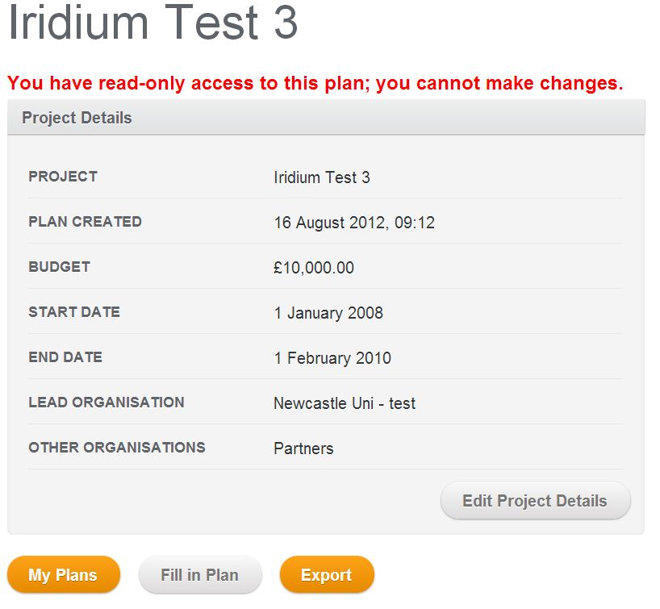
Figure 19: A shared plan with only read rights, at the top of the project details section a note will be given informing the user of the rights he/she has for that specific shared plan. Notice buttons in grey are buttons not accessible in a plan with only read rig
Plans that users are sharing with you (of which you were not the original author) will appear in the Shared Plans section as seen in Figure 1. All other plans (of which you were the original author) will appear in the My Plans section.
Once you have shared a plan, the Project Sharing section as presented in Figure 11, will look like Figure 21. This figure shows the e-mail address of the person that you are sharing with and the type of rights you provided. From this window you can send a notification to the user that you are sharing with by clicking on the Send notification button.
Figure 20 Project sharing section, now showing the users you are sharing with
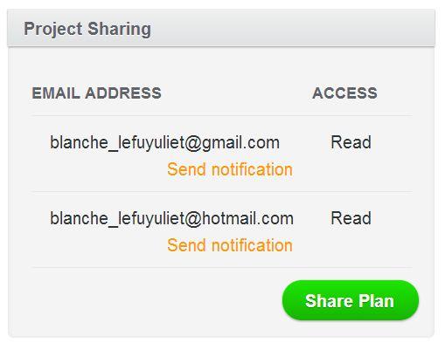

My plans – filling in a plan
My Plans button Figure 22 takes you My Plans section Figure 23 where you can look at all the other plans you that have created, and from here you can Review or Export any plan. You can also Create a New Plan if you wish to.
Figure 21: My Plans button
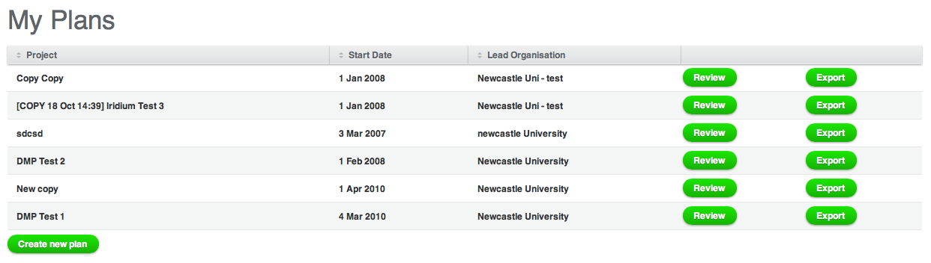
Figure 22: My Plans section, here you can see all your existing plans, review or export them or even create a new plan
Fill in Plan button lets you populate a plan. The set of questions that you are presented with will depend on the project phase you have selected, either Application or Funded. In Figure 25, the selected phase is Application (orange highlighted). When you click on the Fill in Plan button this is the phase of the project that you are going to be working with. If you wish to work with another project phase, just click on the appropriate phase button.
Figure 23: Edit Plan Button
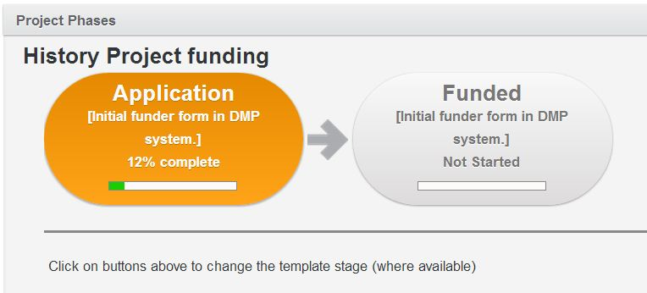
Figure 24: To edit a plan you need to click the project phase you want to work with
Once you have selected the phase of the project you want to work with, you will be ready to start populating your plan. 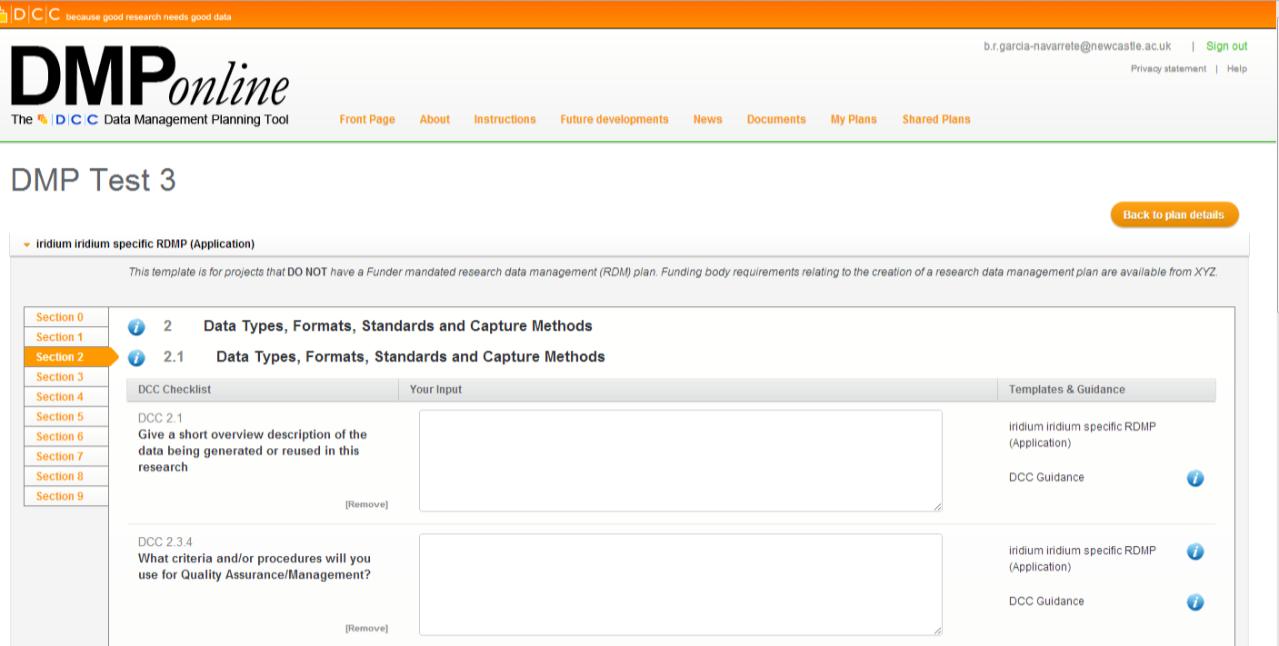
Figure 25: A plan template showing its different sections and utilities
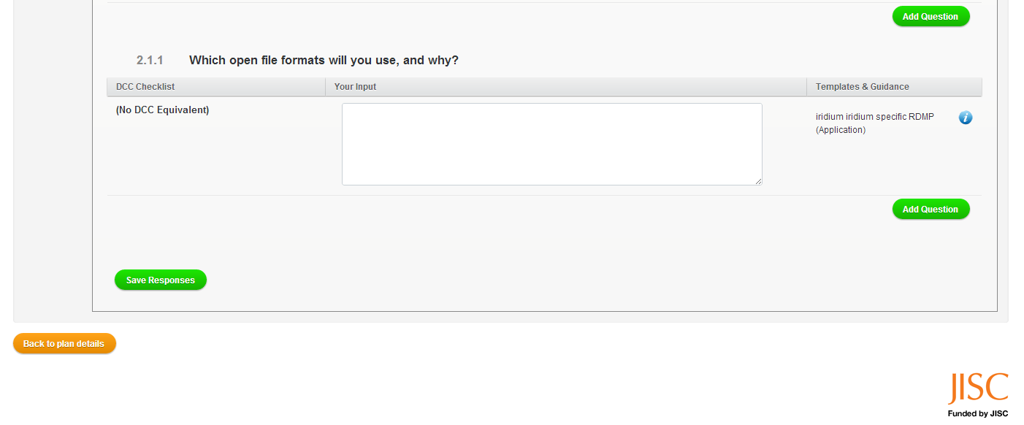
Figure 26: At the bottom of each section you will find the Save Responses button, click on it to save any changes to your plan
You will notice that questions are grouped into sections depending on the theme. You may need to address all of them in order to complete your plan template.
Some of the sections that you may be required to complete are:
- Introduction and Context
- Data types, formats, standards and capture methods
- Ethics and intellectual properties
- Access, Data Sharing and Reuse
- Short-term storage and data management
- Deposit and long-term preservation
- Resourcing
- Adherence and review
- Statement of agreement
- Annexes and other issues
The content in these sections may vary between templates. Labels may also be different or some sections may not even be used for some templates.
You will also need to click on the Save Responses button if you want to save your changes, not clicking on it and leaving the page will result in the loss of all your responses. As you populate the plan, you will be able to monitor the progress of the completion of the template (see Figure 28) from the plan home site (see Figure 11).
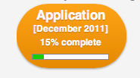
Figure 27: Application phase showing progress on its completion
Another useful feature that will help you answer each question is the Information button (where available), see Figure 29. Each time you click on this button, a new window will pop up offering you information and guidance about the question you need to answer, see Figure 30. The source of this information comes either from the DCC or from the funder guidance.
Figure 28: Information button | 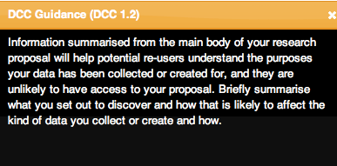  Figure 29: Once you click on the Information button, you will be offered help about the question you are trying to complete, a pop up window will appear
All of the questions provided in each template are mapped to funders’ requirement.
Another tool that you may find useful is the Add Question button which allows you to add more questions to your template from a list provided. You will notice that questions are grouped into sections, if you click on the Add Question button then that question will be added to the template, but to the group that question belongs too (not to the section you are working at the moment, unless that question belongs to that section). The Add Question button in grey belong to questions that are already in the template, green buttons correspond to questions that are available to be added.
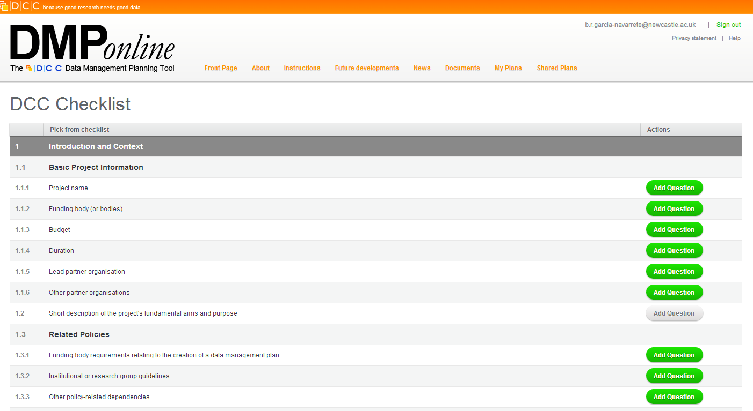
Figure 30: Add question page, from here you can add question to the template you are working with

Exporting a plan
The Export button allows you to export any plan to another format.
Figure 31: Export button
First, you will need to select which plan phase you would like to export by clicking on it; the phase that you select will be highlighted in orange, see Figure 33.
Figure 32 Project phase selection for exporting | Figure 33 Combined output option
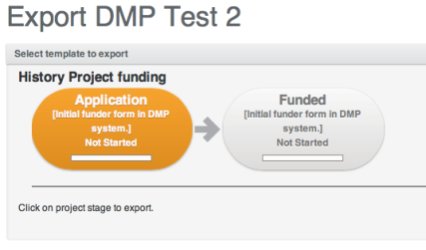 | 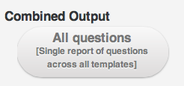
Alternatively, if you are working with more than one funder, and your project includes several templates, you will be given the option to produce a combined output, see Figure 34.
Next, you can select which details of the project you want to include in the exported document. You can also change the header and footer of the document, see Figure 35.
Figure 34 Here you can select what to export | Figure 35 Change the order of the sections or dismiss sections
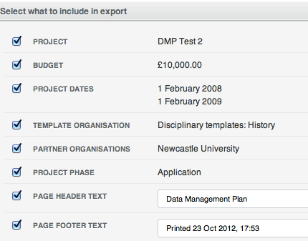 | 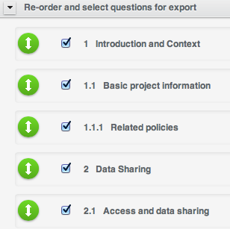
You can also re-order the sections, or exclude sections that you do not wish to include, see Figure 36.
Several formats are available for you to use. Some of them are: PDF, HTML, CSV, TXT, XML, XLSX, DOCX and RTF. Once you have selected your preferred format, you can click on the Open in Browser or Download button. The first will open the file in the browser that you are using; downloading the file will save it to your PC. If you click on the button Back to plan details you will be cancelling the export process.
Other features that you can change are: Layout, Paper Orientation, Font Size and Font Style, as seen in Figure 37.
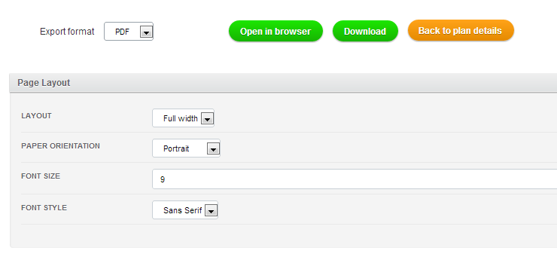
Figure 36: Export format options and page layout options

Locking, duplicating and deleting a plan
Plans can be locked for editing when complete, duplicated to allow parallel editing or deleted entirely. To do so you will need to use the appropriate buttons shown in Figure 38.
Figure 37: Lock, Duplicate and Delete buttons
If you lock a plan, you will never be able to unlock it, so be careful when doing so. You can share a locked plan with another user, and the other user won’t be able to see anything unless he/she exports the plan or duplicates the plan.
Duplicating a plan creates a copy of that plan, and these copies will be independent from each other.
Deleting a plan, deletes a plan forever. You will be asked if you are sure you want to delete the selected plan.
After locking you can duplicate the plan if you really need to edit it, but remember that it is a new plan.

Digital Curation Centre. DMP Online Welcome site. Retrieved October 23, 2012, from https://dmponline.dcc.ac.uk

