CHANCHÁN RIVER BASIN

Localization

The inter mountainous Chanchán river basin is located in the centre of Ecuador in the Andean region, more specifically the occidental mountain range between UTM (17S) coordinates 741151-9776650 (N), 764622-9766493 (E), 762745-9742253 (S) and 705132-9750703 (W). The lowest point is 340 m a.s.l. and the highest point is at 4480 m a.s.l.

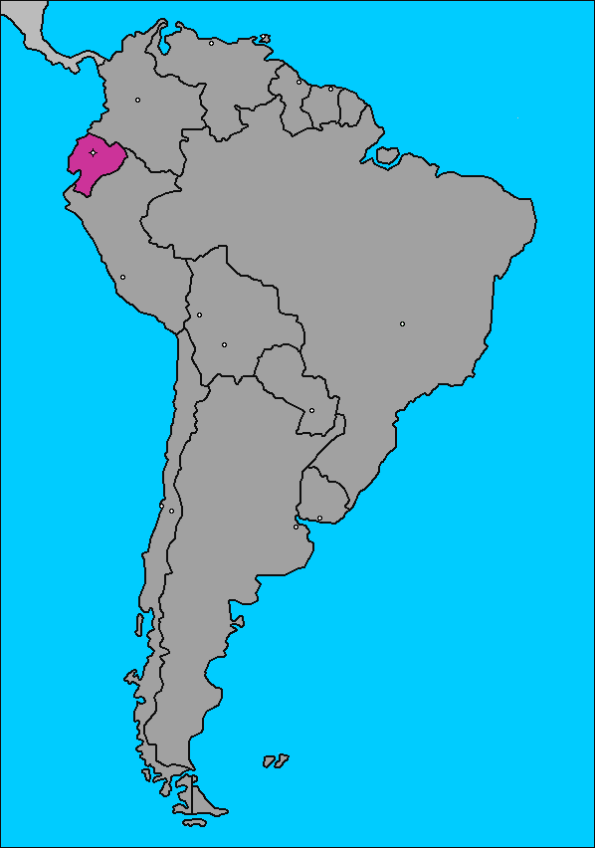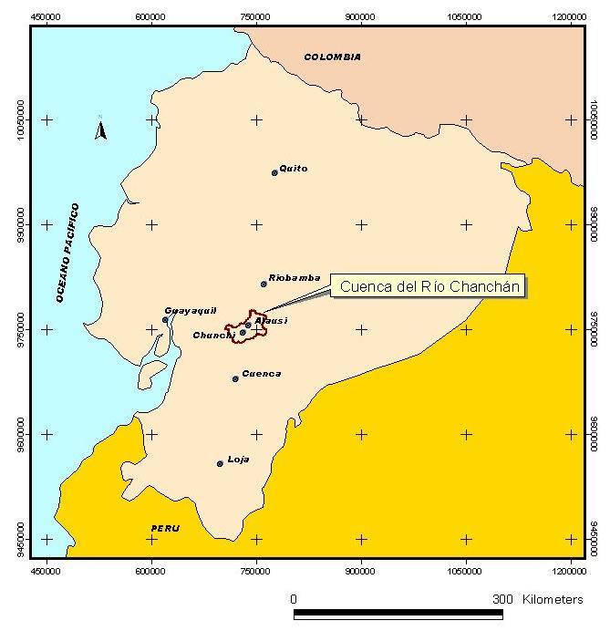

Map of the river basin

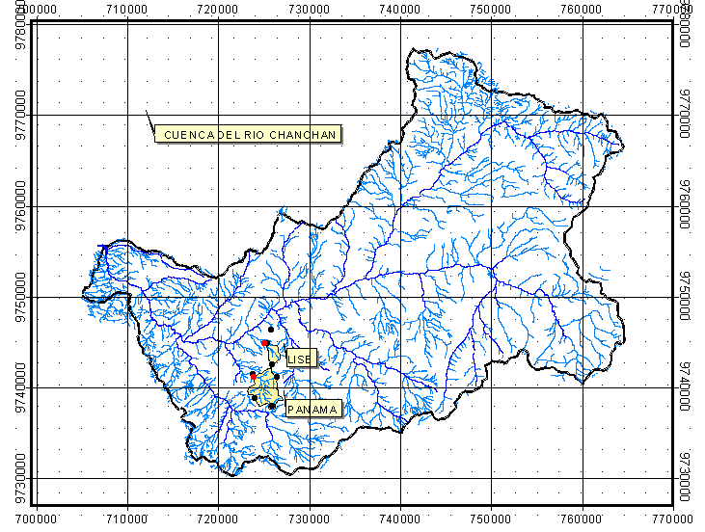
Localization of the Chanchán river basin

Photographs of the river basin

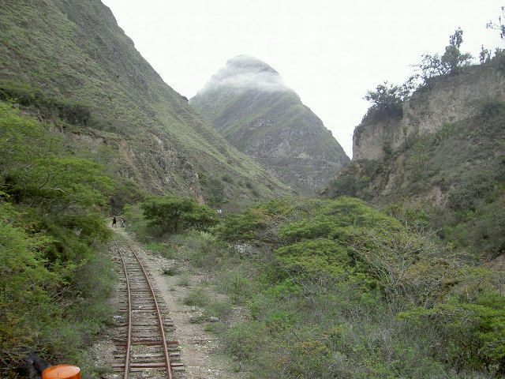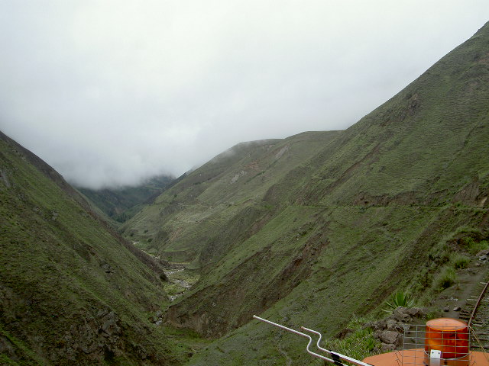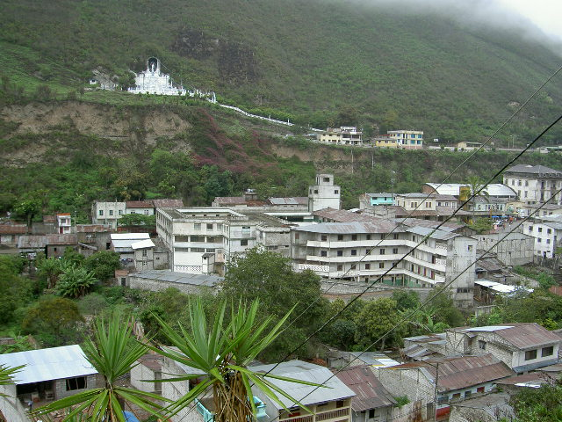

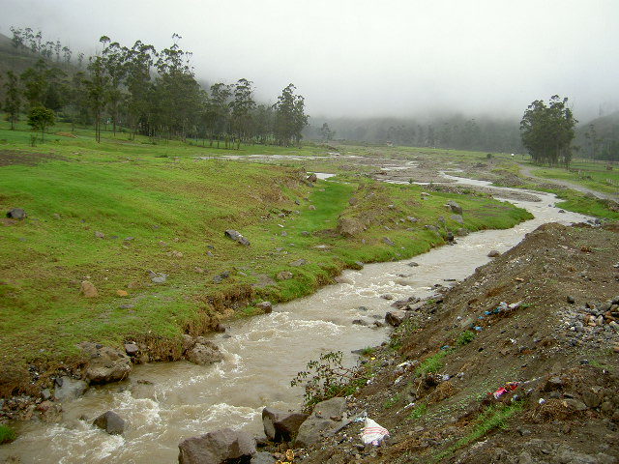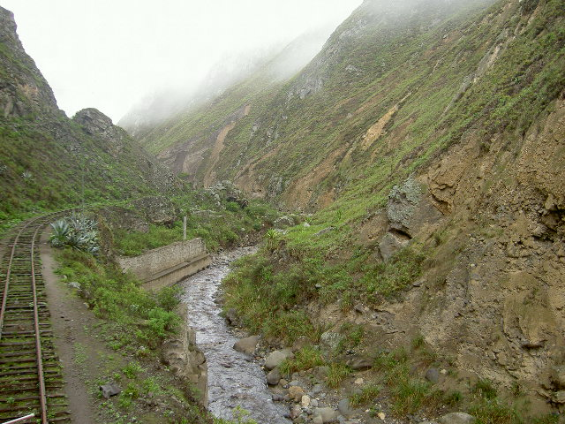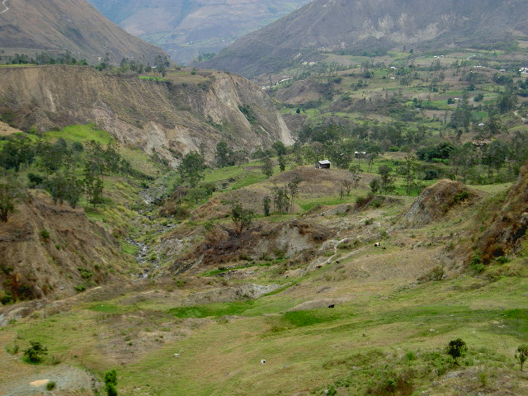

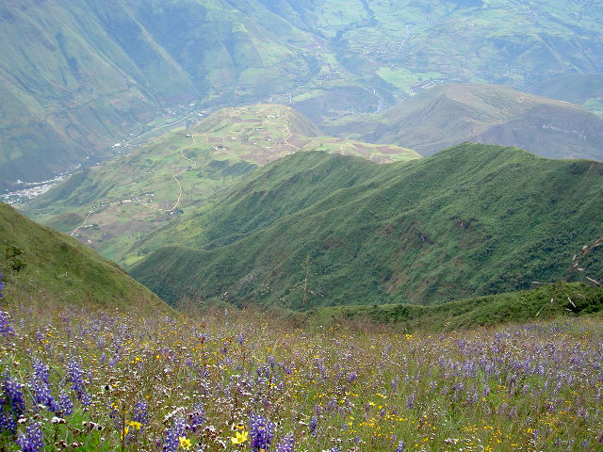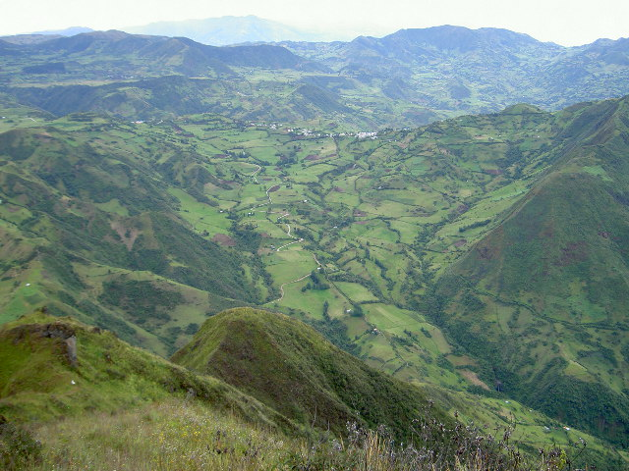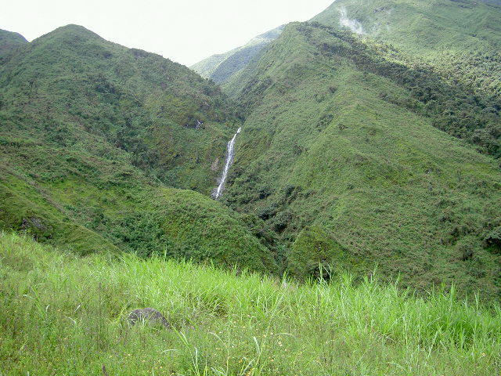

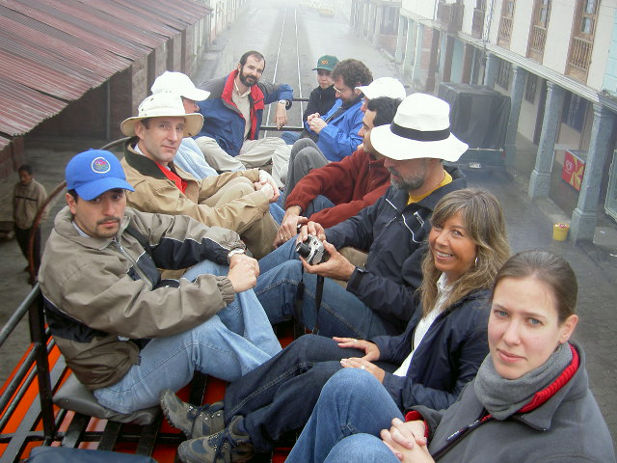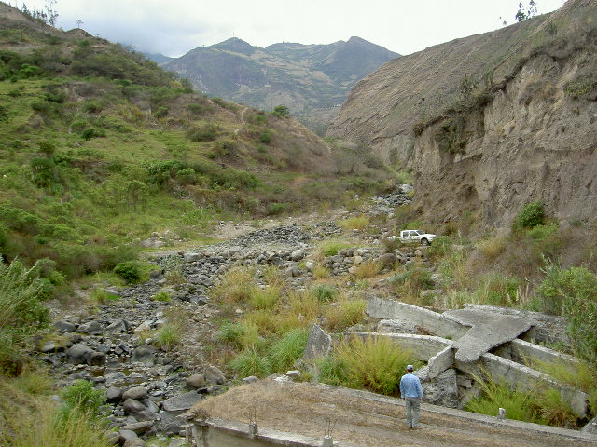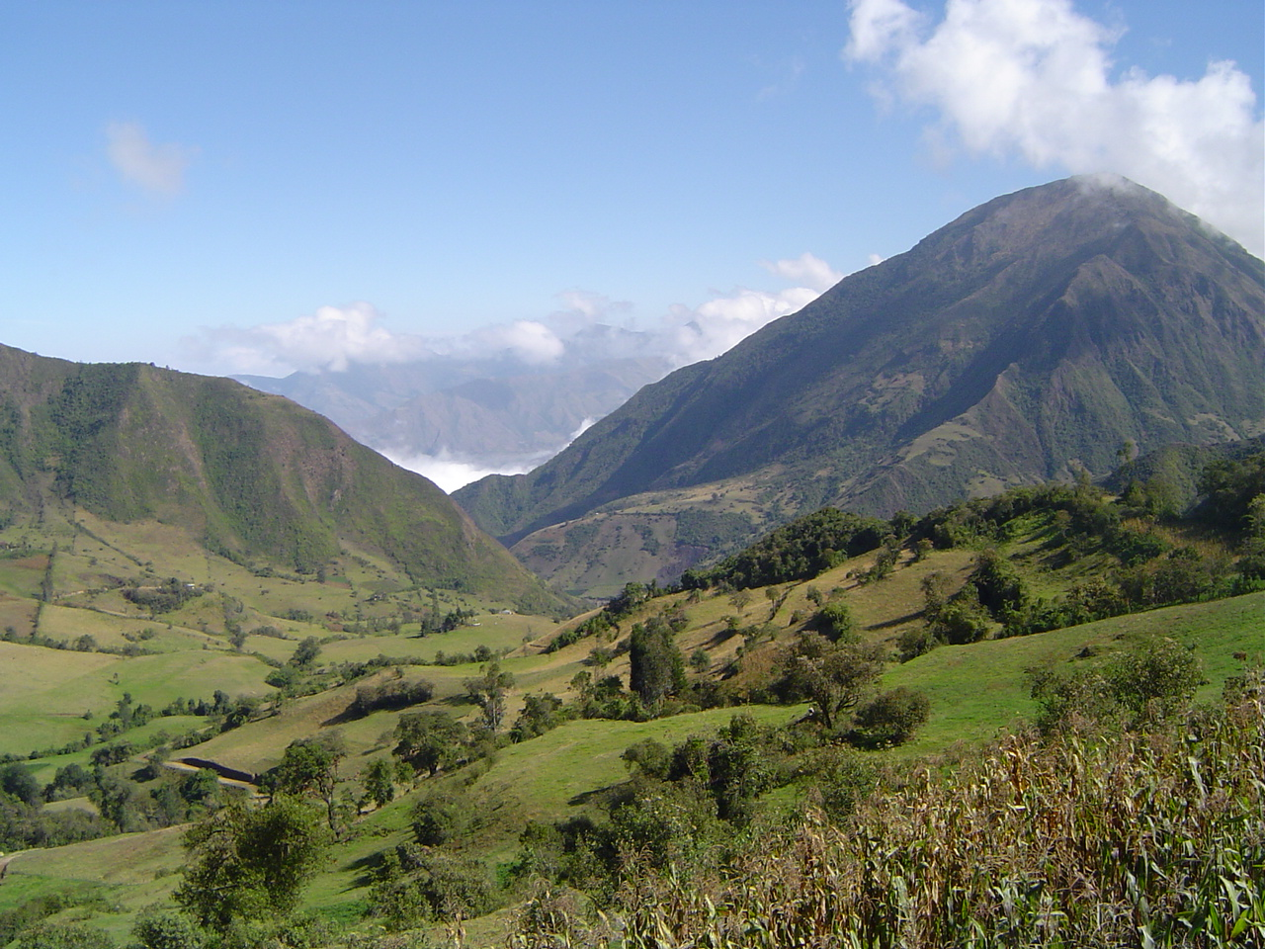
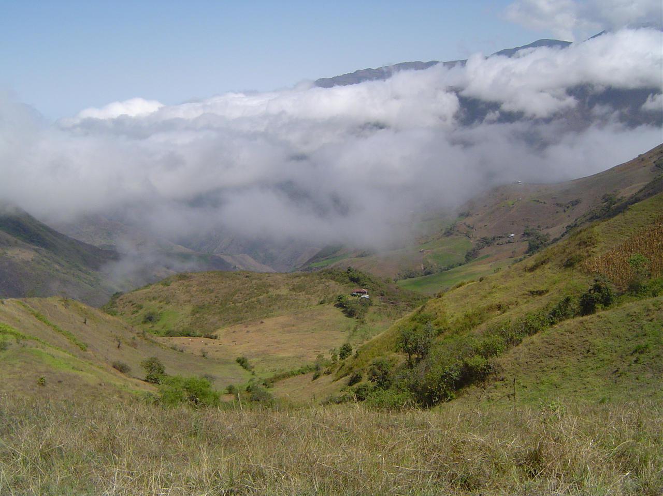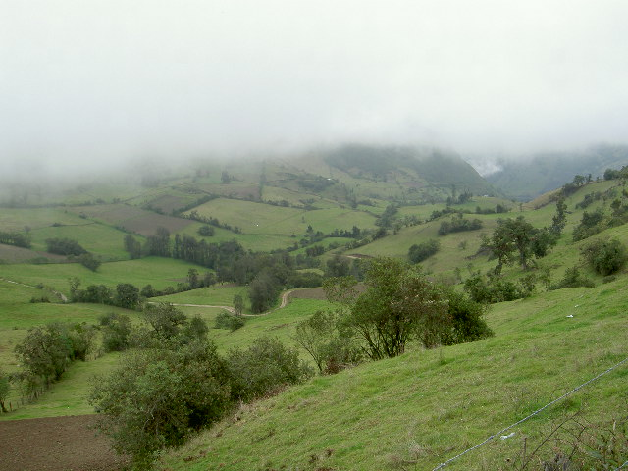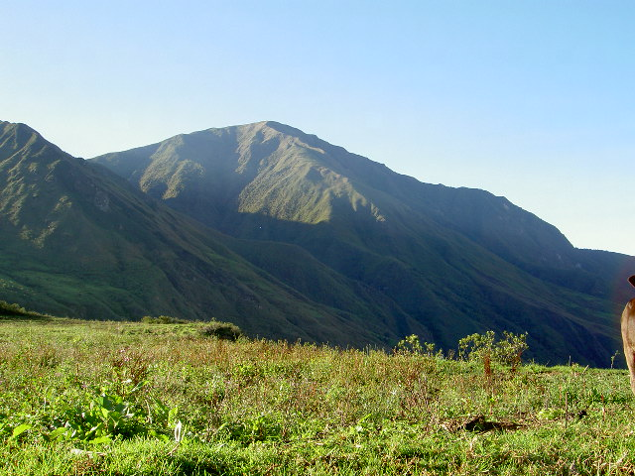

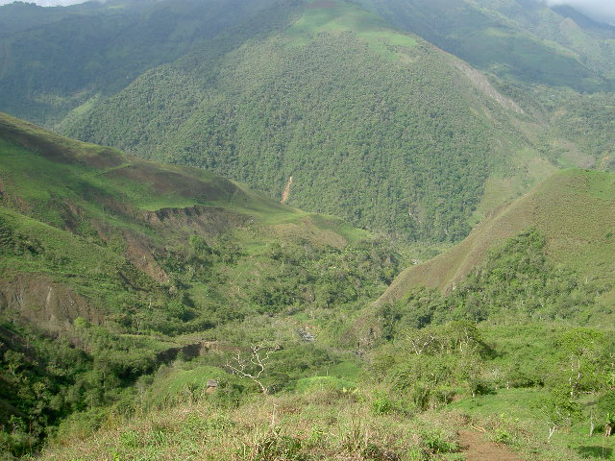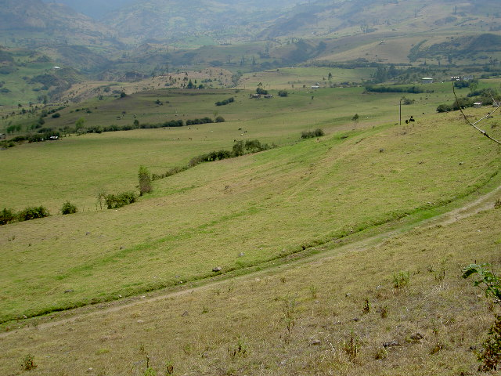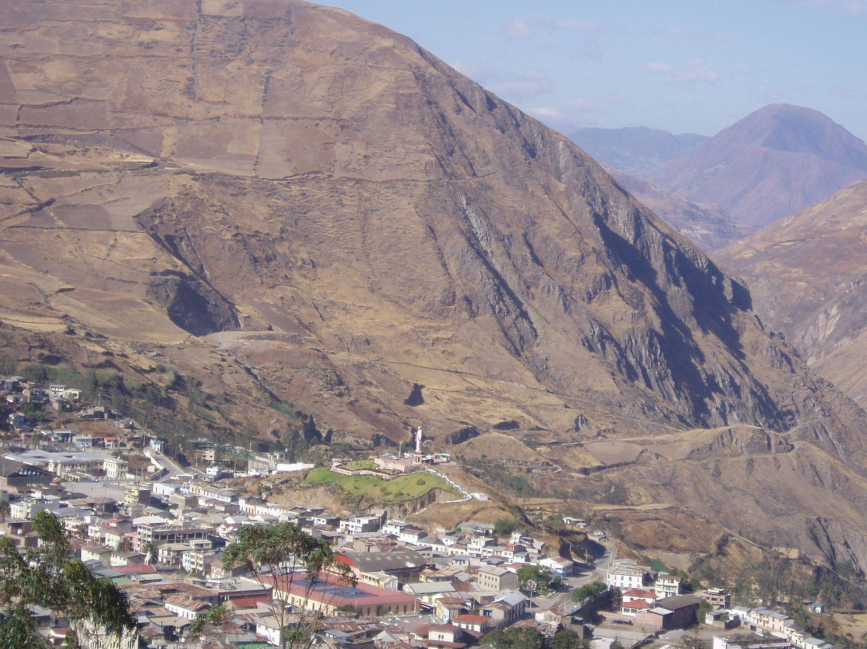

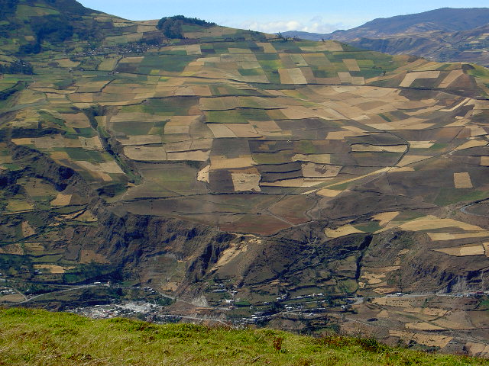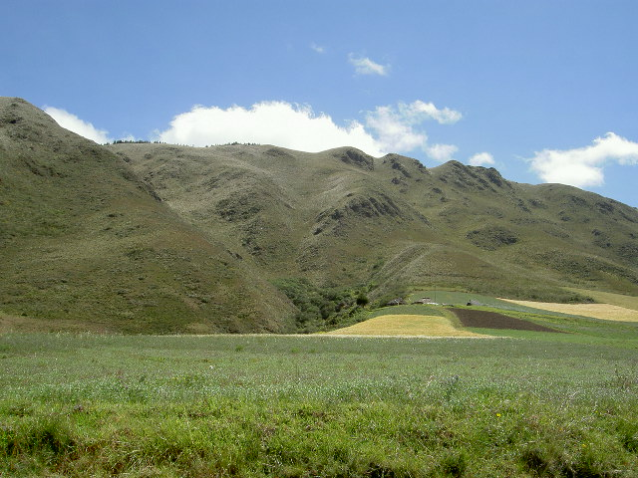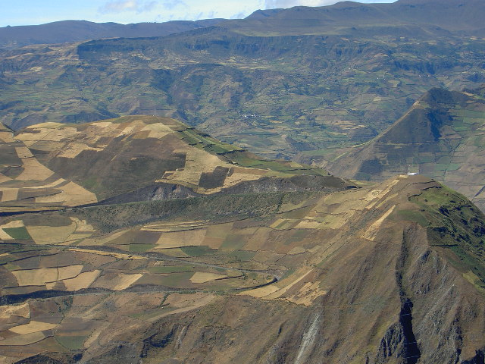
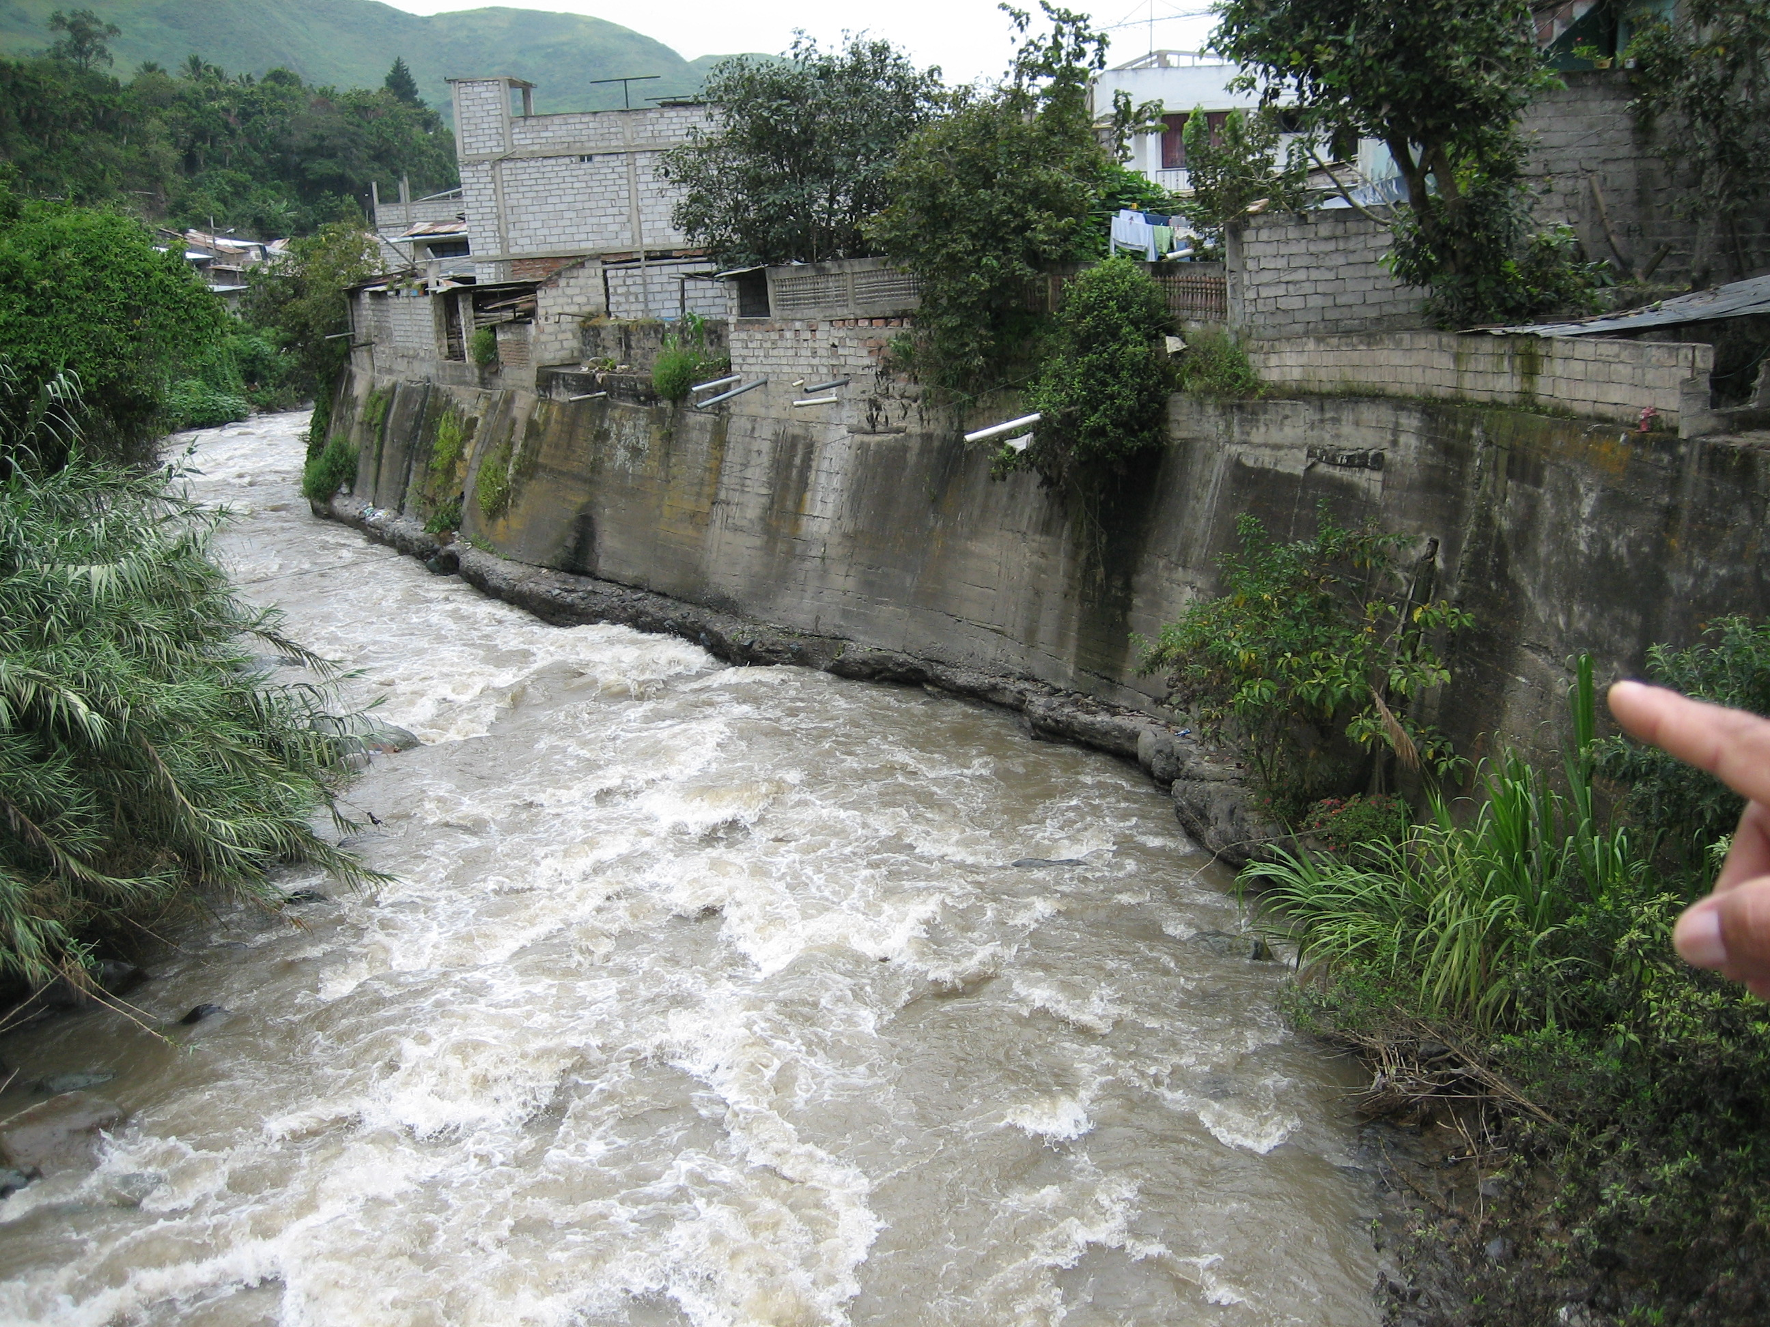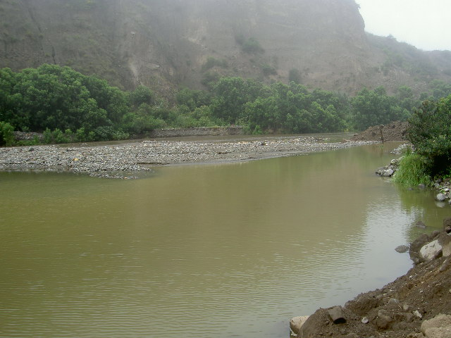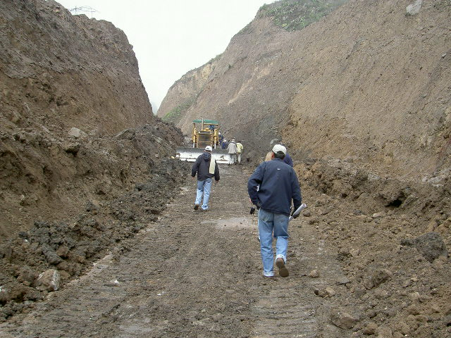

Description of the Chanchán river basin

Morphology and topography

The Chanchán River is part of the Guayas river basin, which flows into the Pacific Ocean. The Chanchán River is the result of the union of the Alausí and Guasuntos rivers, which rise in the ‘páramo’ region in the oriental mountain range. Downstream there are confluences with the Machángara, Blanco, Chinguancay, Chilicay and Azul rivers on the right bank, and Huatacsí, Guabalcón, y Angas on the left bank.

The highest point in the western mountain range is found in the south of the basin: the Boliche hill (4480 m a.s.l.), in the upper part of the Chullabamba basin. In the ‘Cordillera Real’, the highest point is Aquililloma (4198 m a.s.l.). The lowest part is found in Cumandá, in the west of the basin, where the Azul river unions the Chanchán river (340 m a.s.l.).

The rather plane areas, with slopes between 0-12% are found in the east (Pungapala, San Francisco, Palmira, Totoras) and in the lowest region of the river basin (San Jacinto, San Vicente). In the other regions, extreme slopes (> 45%).

Geology

The inter mountainous Chanchán river basin is located between the ‘Cordillera Real’ and the ‘Cordillera Occidental’. Both mountain ranges were formed in orogenic episodes: the Paleozoic and the Mesocenozoic, respectively. The dominant structural characteristics are the large faults in approximate NE-SW and NNE-SSW orientation. The principal faults mark the contacts between several strata. The Chimbo fault divides the Macuchi rocks of the Angamarca turbidites; the Multitud in the SE divides the Angamarca group of the Pallatanga basalts; and the Bulubulu fault divides the Pallatanga unit of the metamorphic base.

Climate

The climate is cold in the páramo region of the two mountain ranges. In the north, the topography is more plane than in the rest of the basin. This has allowed the development of agricultural activity, although commonly these regions are left covered with páramo vegetation (Stippa spp.). This is of enormous importance in the regulation of the hydrologic cycle, as this ecosystem is particularly vulnerable to erosion processes and irreversible degradation.

In the lower parts of the river basin interandine river valleys are found, with a temperature ranging from 12 to 22 º C, with agricultural production, cattle raiser and forest. Besides the altitude, the meteorological characteristics are influenced by the Humboldt and ‘El Niño’ marine currents.

Land cover and vegetation
Land cover is dominated by crops 37%, páramo vegetation 25%, shrubland 17%, natural forest 12% and pasture 7.5%. The short cycle crops are more important than perennial crops, the former found in the whole river basin, the latter mostly found in the lower part.

Soils

Inceptisols (US: Soil Taxonomy, 1975) are found in approximately 50% of the river basin. In the highest and cold parts Andepts and Psamments are found. The areas with Mollisols present 15% of the surface, predominated by Udolls and Ustolls, depending on the climate.

Another group of important soils are the Entisols (25%), predominated by Durandepts and Dystrandepts. The rest of the river basin is covered with associations between these predominant groups.

Extreme events and problems

The extreme rainfall events in the area are related with the ‘El Niño’ phenomenon, which modifies a normal rainy season from January till April in the ‘costa’ region (the El Oro, Guayas, Los Ríos and Manabí provinces) in a more intense (precipitation can reach 4-5 times the normal value) and more prolongated (November till June) rainy season. In the Andes the exceptional rainfalls occur on the slopes oriented toward the west in the Cordillera Occidental, up to 3000 m a.s.l.

The consequences of these events in the coastal region consist mainly in the inundation of agricultural and natural areas. In the mountains the phenomenon causes landslides, with blockade of roads and impacts on human settlements. In general, during an ‘El Niño’ episode, rainfall is too high, which impedes agriculture. This lack of agricultural production causes major impact at country level, forcing the import of provisions.

The majority of the damages occur during and after the intensive rains with duration from 10 to 24 hours, on land which has already been saturated by previous events.

When the ‘El Niño’ phenomenon strikes the Ecuador, the consequences for the national economy are considerable. Losses were estimated 10% of the annual GDP in 1982-1983 and 14% of the annual GDP in 1997-1998.

ANALYSIS OF HISTORICAL INFORMATION

DURATION CURVES
The duration curve is a result of the analysis of frequencies of historical series of average daily discharges. When the historical information is good enough, the duration curve represents the average discharge and can be used to foretell the behaviour of future discharge patterns. In the Chanchán river basin, the Ferrocarril station (Km. 90+180) has 20 years of average daily discharge data, used to derive the duration curve presented in following figure.
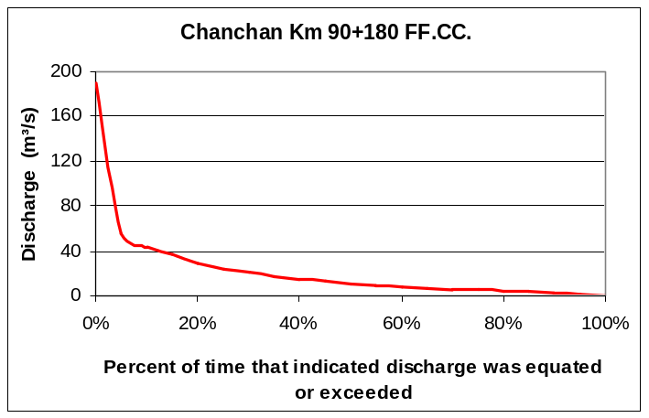
Curva de Duración para la cuenca del Río Chanchan

RETURN PERIODS OF MAXIMUM EVENTS

Information about maximum discharges is available for Chanchán (1965-1985) and Angas (1965-1982) and was used to estimate return periods of maximum events with a Gumbel correction.

Analysis of maximum discharges for the Chanchán station Km 90+180 FF.CC.

The contribution area for this station is 1480 km². Available information are instantaneous annual maximum levels of the entire series and instantaneous maximum discharges in the 1982-1985 period. Determination of missing instantaneous maximum discharge data was done through discharge curves.

Annual discharge maxima are shown in following table.

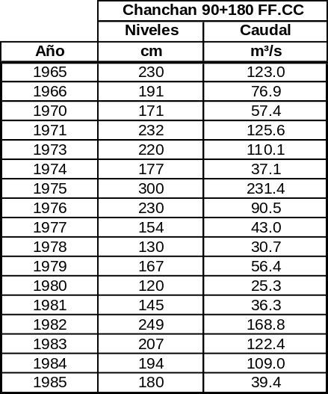
Instantaneous maximum discharge

The estimation of maximum floods and its return period was established through a Gumbel analysis. Results are indicated in following graph.
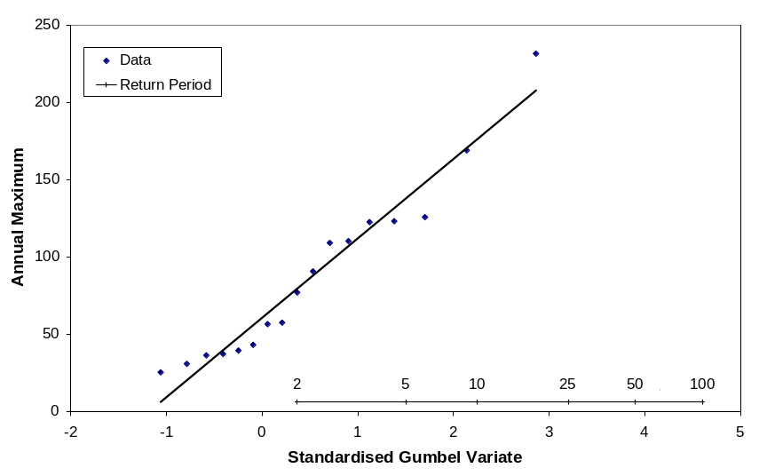
Gumbel frequency curve of annual floods on Chanchan River

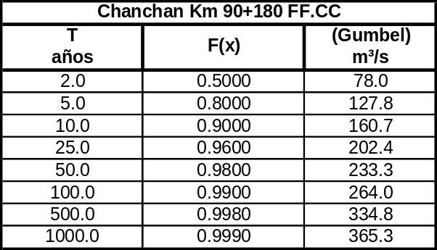
Caudal estimado para diferentes periodos de retorno

THE CHUNCHI LANDSLIDE, 1983

In April 1983, during the most humid year of Ecuador during the 20th century, a land sliding of almost one million m³ occurred in the outskirts of the Chunchi city (UTM coordinates 738814 E, 9752197 N, approximately 120 km north of Cuenca) blocking the pan American highway and burying vehicles. More than 150 people died in the incident.

Available rainfall registrations for all pluviographs 5days previous to the landslide are presented in the following table.

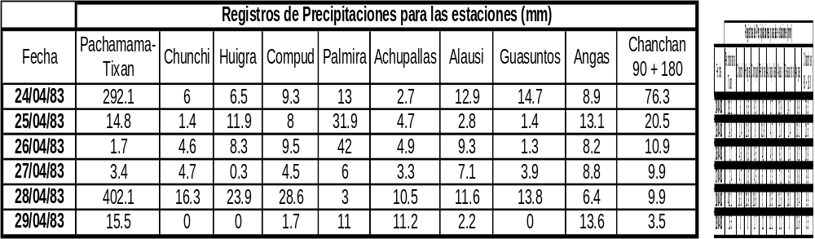

Rainfall registration in the week previous to the Chunchi landslide

The Pachamama-Tixan station registered two extraordinary rainfall events in the week of the disaster. In the first place, a rainfall of 292.1 mm was registered 5 days prior to the land sliding. Secondly, on the day of the incident, a rainfall of 402 mm was registered. 1983 has a return period of more than 100 years for these events.

The figure shows the response to this rainfall event in the Ferrocarril FF.CC. station 90+180 km downstream. The damage to the station is as a result to the major flood is evident, impeding discharge registrations.

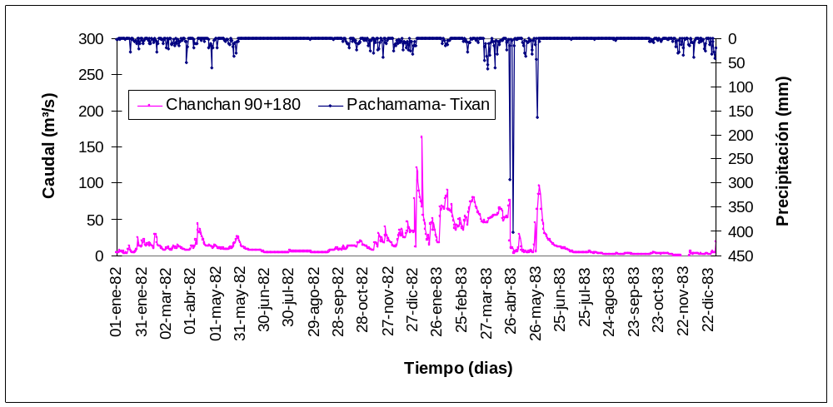
Hydrological response in FF.DD: 90+180 to the Pachamama event

