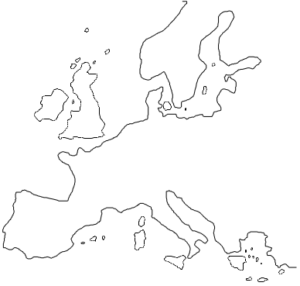
Universität Dortmund
Fakultät Raumplanung
Fachgebiet
Europäische Raumplanung
Spatial Planning in Europe
Aménagement de l’Espace en Europe
D-44221 Dortmund

1
Klaus R. Kunzmann and Lars Tata with Tino Buchholz
Dortmund: A Story of Change

Dortmund, November 2003

City Regions as Intelligent Territories: Inclusion, Competitiveness and Learning
A project funded by the European Commission
University of Newcastle ∙ University of Dortmund ∙ Trinity College Dublin ∙ University of Tampere
Contents:

1 About “Phenix” and “Phoenix”
2 City Region and Governance
3 Population
4 Economy
5 Universities
6 Research Institutions
7 Dortmund - A Learning City?
8 Bibliography

About “Phenix” and “Phoenix”
“Phenix seems to have come out of ash again. All over Germany, newspapers reported the success story to the general public, restoring the damaged image of the city” (Kunzmann, Brosza 1991: 4). If this was a pertinent description twelve years ago the current observer might be less enthusiastic. Nevertheless Dortmund has undergone a remarkable progress and process - to be continued.
More than 200 years of coal mining and steel production gradually transformed Dortmund into an industrial city, so the structural changes are immense. This economic base dominated the city’s urban economic development in the subsequent decades. Along with other industrial areas Dortmund benefited from the success of the railways all over Europe. Industrial labour shortage made the city become an early immigrant city, so economic and demographic growth forced the local government to improve and expand it’s city boundaries. Between 1904 and 1929 some small municipalities were “convinced” to join Dortmund and to become an urban subdistrict. This process of successful local government consolidation, took place until 1975 and has left traces still influencing post-modern politics (Kunzmann, Brosza 1991: 9ff).
During the second World War, Dortmund was heavily bombed and in 1944 95% of the inner city were destroyed. After the war the city became a prominent example of post-war reconstruction. At that time the city’s redevelopment efforts were considered to be a model case for progressive land consolidation and redevelopment. They contributed much to accelerate the economic revival of the city as a whole and the transformation of the inner city into a large commercial supermarket. The speedy reconstruction of the inner city in the 1950s is a heavy legacy and to a great extent it is responsible for the poor aesthetical quality of the city, a fact that contributes to the mediocre urban image of Dortmund and to its low profile as a target for urban tourism (Kunzmann, Brosza 1991: 10).
The pre-conditions are far away from being ideal and it will always be hard to compete with German metropolis like Berlin, Hamburg or Munich in terms of quality of life. Even if disused coal mines and steelworks have become exhibition venues or theatres and the statistics say that Dortmund’s surface area is approximately 50% green, the city and the whole Ruhr Region is still seen as a Rust Belt with little appeal as a place to live.
Since the 1980s, Dortmund and other cities of the Ruhr Region have been trying to tackle this historical image and still do. Dortmund has just opened a new philharmonic hall trying to soften its image. Further the city is very ambitious to build the central station as a new urban entertainment centre, named 3DO, offering 55.000 square metres for shopping. Even if the levitation railway, Metrorapid, failed, the 3DO is still on the agenda, worth more than 500 million Euro, setting “new standards”. The city - home of the BVB 09 - prepares for the Soccer World Championships 2006 in Germany. Several big projects are due till 2006. One of them is also the conversion of the former blast furnace at the Phoenix Area. These relicts of the steel history will be vanished soon, replaced by a lake and comfortable housing. While the industrial era in Dortmund ended, “Phenix seems to have come out of ash again” and so does Phoenix.

City Region and Governance
Realising former politics, “administrative marriages”, industrialisation and the burden of mass destruction Dortmund likely appears as a patchwork of small semi-urban local governments than a homogenous city. Speaking about a patchwork of formerly independent cities within Dortmund, one could even name it a city region. If you widened the perspective the “City Region Dortmund” seems even bigger not considering political boundaries but the strong relations the Industrie- und Handelskammer (IHK) (“Chamber of Industry and Commerce”) built up. Dortmund is the headquarter of the IHK representing not only Dortmund but also the city of Hamm and the district of Unna covering the cities and municipalities of Bergkamen, Bönen, Fröndenberg, Holzwickede, Kamen, Lünen, Schwerte, Selm, Unna and Werne. This formal IHK unit represents a region of about 1.2 million people (www.dortmund.ihk.de, 23.10.2003). Dortmund not only fulfils core centre functions for that region which covers especially the eastern periphery but the city acts in a similar manner for nearby cities such as Witten in the south-west and Castrop-Rauxel in the north-west. Considering that we speak about a city region with a population of around 1.5 to 2 million.
Declared aim of the city council was and still is to consolidate the city’s function and position as an regional high-order-centre and convert it into a future-oriented technology and service centre. Due to this fact and to the comparably bad image of the Ruhr Region Dortmund stays busy separating while emancipating itself as the “Heart of Westphalia”.
Figure 1
Location of Dortmund within the Ruhr Region
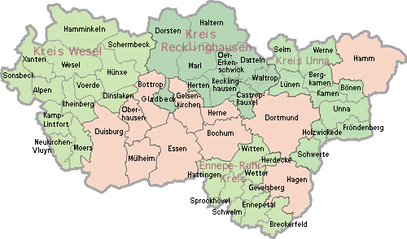
Source: www.kvr.de, 10.09.03
But the regional dimension can be seen in a further different way. If one considered the quite similar developments the city neighbours (Bochum, Essen, etc.) went through Dortmund again is only one part of an impressive agglomeration: the Ruhrgebiet (Ruhr Region) (Figure 1) covering approximately 5.4 million people in the inner area (www.kvr.de, 10.09.03) and about 12 million people (Brödner, Rücker 2003: 2) within the metropolitan Rhine Ruhr Region (Figure 2). In both cases, Dortmund marks the eastern arch.
The coal never cared about administrative boundaries, it simply let them vanish – not only within the Dortmund city district but all over the Ruhr Region. This is how the Ruhrstadt (“Ruhr City”) idea – as a comprehensive unit – was born pushed and promoted by several cities from the centre of the Ruhr Region and combated by the cities located at the western and eastern edge of the region like Duisburg and Dortmund. Even though Dortmund does not get tired to define itself as the “Heart of Westphalia” and to emphasize the differences to the Ruhr Region it shares the history and traditional development of coal and steel within the Ruhr Region. That fact might have convinced the lord mayor of Dortmund to sign a “city region contract” - including the eight biggest cities of the Ruhr Region - to strengthen regional and administrative potentials and synergies and to end ruinous intra-regional competition (www.ruhr-2030.de, 23.10.2003).
Figure 2
Map of the Metropolitan Rhine Ruhr Region
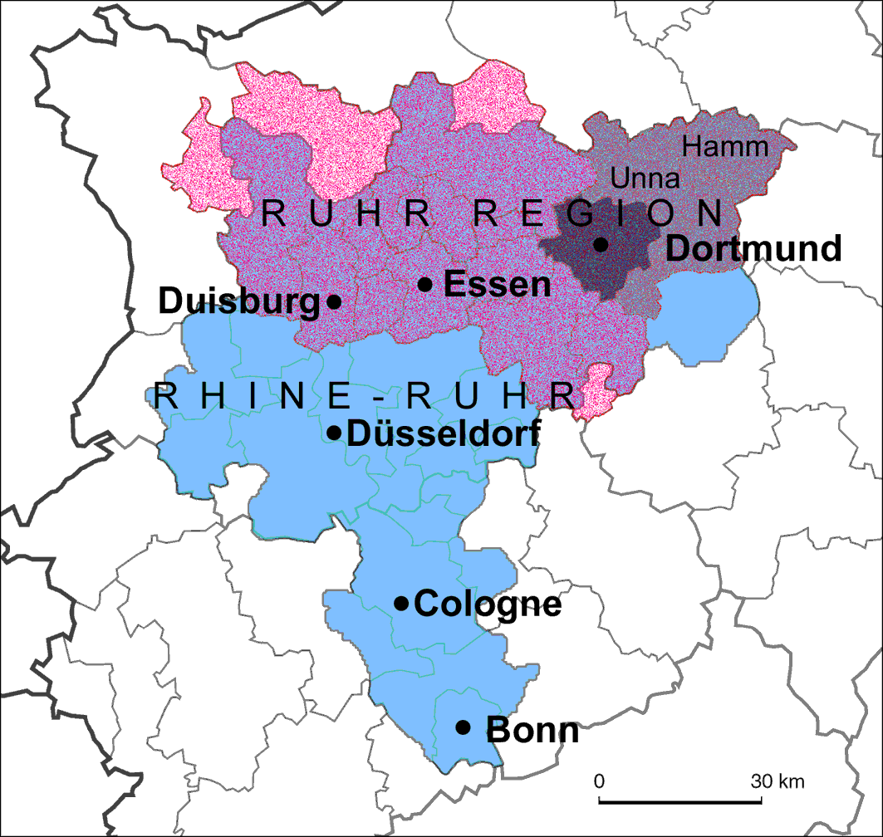
Source: Brödner, Rücker 2003: 2
However the state government of North Rhine-Westphalia (NRW) preferred to support other formations of collaborations on the regional level. One strategy which was implemented in the late 1980s is called “regionalised structural policy” aiming to initiate sub-regional collaborations as a top-down strategy. Therefore the Ruhr Region has been divided into six different sub-regions which correspond to the IHK units. Regionalkonferenzen (“Regional Conferences”) ought to support the development of innovative ideas and projects by bringing together different regional actors and key players. Apart from a small amount of exceptions this strategy is seen as failed. Because of its size the Regional Conferences only managed to meet once a year and have never been more than ´talking rounds` (Heinze et al. 1997).

While there are Regional Conferences to the smaller regional units, the IHK units, there is the Ruhrparlament (“Parliament of the Ruhr”) to the whole Ruhr Region administrated by the Kommunalverband Ruhrgebiet (KVR) (“Association of Local Authorities in the Ruhr Region”). The political decisions for the region are due to the Ruhrparlament assisted by expert committees. The parliament is represented by the eleven autonomous cities and the four official districts which all are all obliged members to the KVR (www.kvr.de, 24.10.2003). This might change soon since the KVR is not the strong regional institution it could be. It has poor political power and has even not the planning authority for the Ruhr Region but it acts as “marketing and tourist agency”. Presently the state government of NRW is planning to change function and role of the KVR.
On the same level there is also the Projekt Ruhr GmbH founded by the state government of NRW in 2000. This organisation operates parallel to the KVR but is even more powerful while in charge of money given by the EU and the state of NRW. The original idea of establishing this institution was not to start an initiative in addition to the KVR but to replace it. Due to the heavy political protests the state government came up with the tandem solution. The main goal is to initiate activities and innovative projects such as the “Ruhr Triennale” which has been successfully implemented as a high-quality cultural event as well as it takes care of the continuing projects of the Internationale Bauausstellung (IBA) (“International Building Exhibition”).

Population
In times of an aging society and sub-urbanisation Dortmund ranks among the ten leading cities (7th) - 9th in spatial size - of Germany. With 2.100 inhabitants per square kilometre Dortmund is an urban settlement of average density in relation to the whole Rhine Ruhr Region which itself is one of the densest agglomerations in Europe. Counting little more than 590.000 inhabitants in 2003 (www.dortmund.de, 25.10.03) the city managed to meanwhile end of process of decline. After losing parts of the population to the neighbouring communities for several years, e.g. to the district of Unna, Dortmund now shows a slight increase advancing to be the biggest city of the Ruhr Region – a reputation the city is very proud of. While Essen still claims to be the top-ranked city one needs to realise these two biggest cities developed differently. Because of its size and the potential of undeveloped areas Dortmund is still able to run housing projects outside the urban city centre while Essen is not.
Reaching its peak in the early 1980s and again in 1990 - attributable to the immigration in the context of German reunification - Dortmund was marked by losses since 1995 caused by a mixture of low birth-rates and migration. On the other hand the county of Unna for instance has gained by over 6% in terms of population since 1990 (Table 1). One of the reasons is the green environment of the Unna periphery, which continues to attract many people, in particular families.
Table 1
Population of Ruhr Region - selected overview
Area | Population
Area | Total |  | Density  (people per square km)
Area | 1990 | 2001 | 1990 | 2001
Bochum | 396.486 | 390.087 | 2.727 | 2.682
Bottrop | 118.936 | 120.780 | 1.182 | 1.200
Dortmund | 599.055 | 589.240 | 2.138 | 2.102
Duisburg | 535.447 | 512.030 | 2.300 | 2.199
Essen | 626.973 | 591.889 | 2.981 | 2.814
Gelsenkirchen | 293.714 | 276.740 | 2.801 | 2.640
Hagen | 214.449 | 202.060 | 1.337 | 1.260
Hamm | 179.639 | 183.805 | 795 | 812
Herne | 178.132 | 174.018 | 3.466 | 3.385
Mühlheim | 177.681 | 172.332 | 1.947 | 1.889
Oberhausen | 223.840 | 221.619 | 2.906 | 2.877
Autonomous cities of KVR total | 3.544.352 | 3.434.600 | 2.109 | 2.044
Counties of KVR | 1.851.856 | 1.912.550 | 673 | 695
KVR total | 5.396.208 | 5.347.150 | 1.217 | 1.206
NRW | 17.349.651 | 18.052.092 | 509 | 530
Germany | 79.753.000 | 82.441.000 | 223 | 231
Source: www.kvr.de, 26.10.03
Compared to cities such as Hamburg, Cologne (Köln), Frankfurt and Munich (München) the development of population was negative during the last years (Figure 3) owing to the heavy structural problems of the Ruhr Region.
Figure 3
Population development 1990-2002 (%)
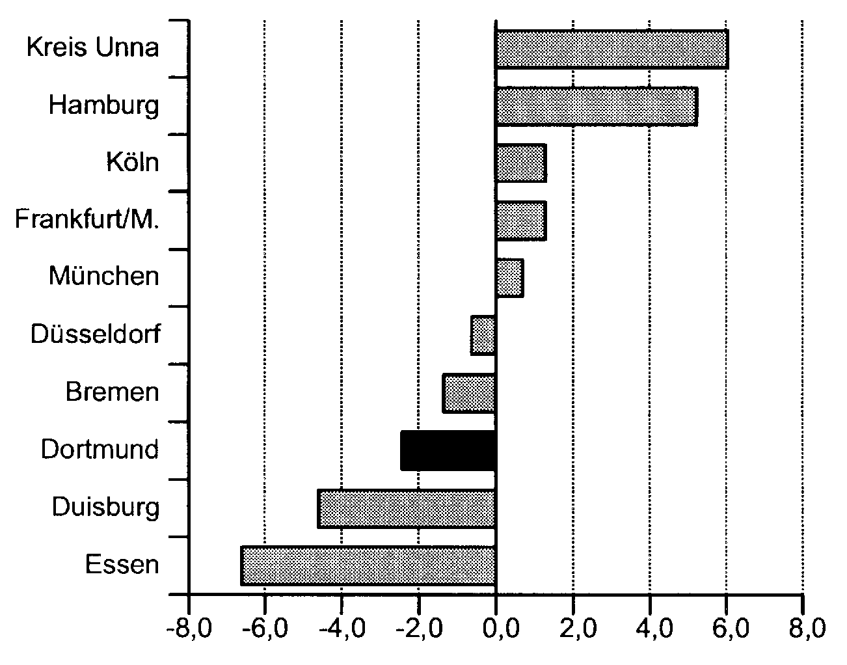
Source: Stadt Dortmund 2003: 21
In 2002 75.232 of Dortmund’s population were migrants from other countries, representing 12,8% of the total population. The majority of these (37,1%) were migrants from Turkey, while 17,9% were from EU countries. Since 1990, the number of inhabitants with foreign origins has grown by 18,9%. The northern inner-city district known as Nordstadt is the traditional migrant quarter, where social and structural problems are also to be found. Consequently, for many years social and urban-development measures have been in place in the Nordstadt district (Stadt Dortmund - Statistik und Wahlen 2003: 14).

Economy
The economic roots of Dortmund go back in the 13th century when the city was a member of the Hanse, one of the most powerful trade associations in northern and central Europe these times. A great progress the city experienced during the second half of the 19th century, when coal, steel and beer attracted the attention and became sustainable resources to push economic and social developments.
At the beginning of the 1960s the coal mining industry began to decline resulting in a great loss of jobs. In the 1970s the steel industry and the breweries of Dortmund came in trouble. The number of jobs in these core industries was reduced from 80.000 in 1960 down to 9.200 in 1997 (Figure 4). Today there is no working coal-mine left and when the “Westfalenhütte” was closed in March 2001 so an entire era of steel production ended in Dortmund.
Figure 4
Development of jobs in the old core industries in Dortmund from 1960 - 1997
(1 in 1000)
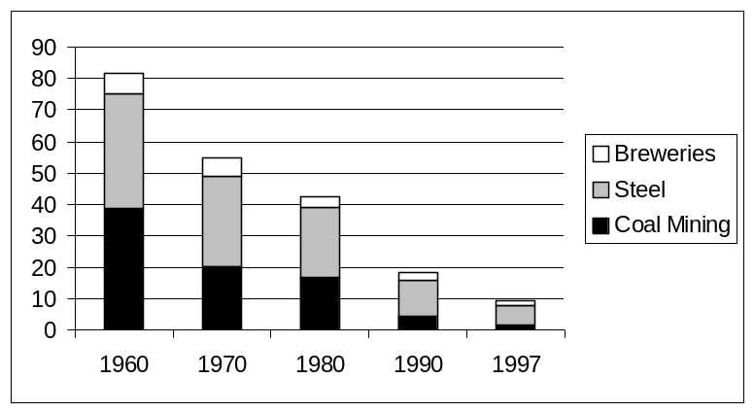
Source: www.dortmund.de, 01.10.2003
The drastic loss of these structures were only in part to be compensated by jobs out of the service sector and the new economy. The unemployment rate for the city district of Dortmund in July 2003 was comparably high at 14.5%, two% over the Ruhr average and clearly over the average of the state NRW and overall Germany (Table 2).
Table 2
Unemployment Rate of Dortmund in Relation (Oct. 2003)
Region | Rate
Dortmund | 14,6
Ruhr Region (KVR) | 12,0
NRW | 9,7
NRW without KVR | 8,8
Germany (West) | 8,0
Germany | 10,0
Source: www.kvr.de/daten/statistik/bindata/arbmarkt_112003.pdf, 26.11.03
Although Dortmund's GDP has grown in recent years, it is significant that Dortmund’s economic strength has weakened against the German average at least during the 1990s. In contrast to the other metropolitan cities with 54.000 euro Dortmund’s GDP per capita balances comparably low in 2000. Only the county of Unna and Berlin mark even lower standards – Düsseldorf ranks first with 80.000 euro per capita. Analysing the development from 1992 till 2000 the GDP appears to have improved for no more than 12%, only leaving Berlin and Essen behind (Figure 5).
These numbers show the city as well as the region still suffer from the radical structural changes they face and it will take even more effort and strength to balance theses losses well. The transformation of the region towards services and high-tech industries received strong political backing – sometimes of a more, sometimes of a less efficient nature.
Figure 5
GDP per Capita in 2000 (in Euro) and
Development of GDP 1992-2000 (1992 = 100)
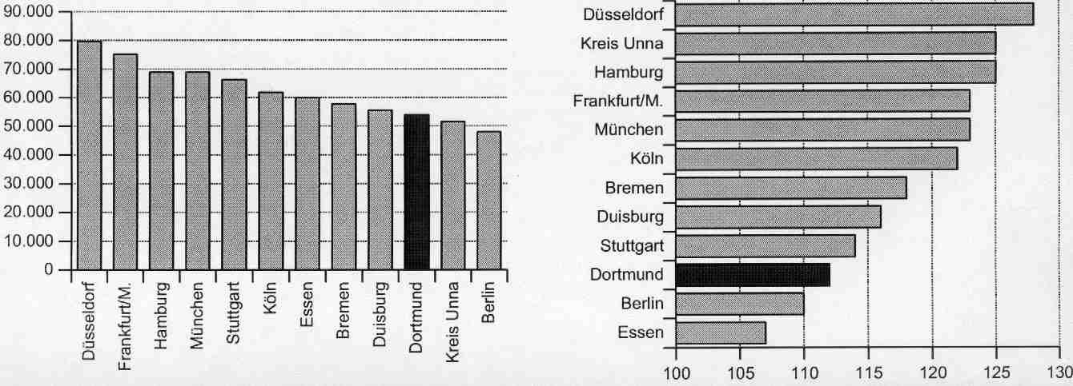
Source: Stadt Dortmund 2003 - Statistik und Wahlen: 17
Along with other German cities of this size Dortmund concentrates on the service sector. 75% of all employees work in the tertiary sector (Figure 6). While the steel company Hoesch as formerly biggest company with more than 26.000 employees in 1975 (Voßschulte 1996: 410) does not exist anymore today the city council employing about 7.600 (Stadt Dortmund 2002: 78) and the Universität Dortmund paying about 3.000 people (www.uni-dortmund.de, 23.10.03) are the biggest employers.
Divided by branches the logistics-sector is the most improving. 625 enterprises with more than 21.000 employees are busy within the differing segments of “transport, transfer, storage”, “logistics-centres of trade” and “supply of technology and equipment” (Wirtschafts- und Beschäftigungsförderung Dortmund 2003a: 12). Further, Dortmund has advanced to be known as a technology location in the last couple of years. Other branches of higher value are the IT sector containing 650 companies with 11.800 employees and the MEMS technology that are expected to grow very fast: Currently 20 companies with 1.400 employees almost doubled their number of jobs within the period of 1997 till 2002 (Wirtschafts- und Beschäftigungsförderung Dortmund 2003a: 11).
Figure 6
Employees Liable for Social Security Contributions in 2001:
Dortmund in Relation to the State of NRW and Germany (Bund)
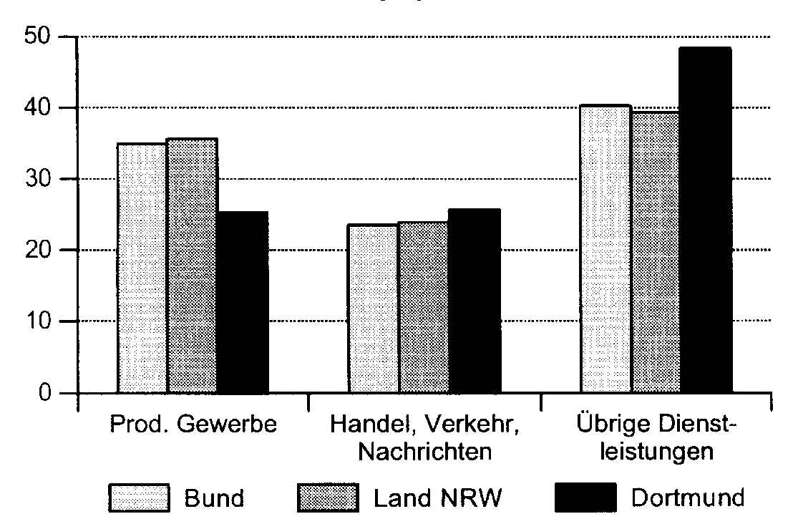
Prod. Gewerbe = Manufacturing
Handel, Verkehr, Nachrichten = Trade, Transport, Media
Übrige Dienstleistungen =
Other Services
Source: Stadt Dortmund - Statistik und Wahlen. 2003: 12
The TechnologiePark is the new home to these new industries and businesses. The park and the TechnologieZentrum as part of it are located right next to the University of Dortmund just outside the city. Since 1985 the TechnologiePark has developed very fast. Today it is one of the successful locations of its kind in Germany. The close proximity to the university and the research institutes is a major factor for its success as it creates strong linkages and promotes knowledge transfer between science and industry. About 200 companies which employ more than 8.500 highly educated people situated on 35 ha benefit from this practical relationship between R&D, industry and service sector. Today there are 230 companies with more than 8.500 employees. An expansion area of 8 more ha is prepared to be developed (Wirtschafts- und Beschäftigungsförderung Dortmund 2003b: 21).
The economic destiny of the city is mainly taken care of by the dortmund-project. This initiative has the ambitious goal to create 70.000 jobs until 2010. With the assistance of the management consulting firm McKinsey & Company the project was started officially in June 2000 installed by the City of Dortmund and Thyssen Krupp AG. Since then the project team's efforts have led to the building of an extensive network of contacts, enabling companies, scientists and opinion leaders in political and social thought to share knowledge and experience with each other. Fostering primarily public private partnerships the dortmund-project focuses on the development of three industries: information technology, microsystems technology and logistics. Besides the promotion of start-ups it intents to support companies in more traditional industries to modernize and re-organize their business processes. Both old and the new economy shall benefit from these close contacts. More than 500 million Euro are going to be invested in pursuit of these goals until 2010 (www.dortmund-project.de, 27.10.03).

Universities
Mental craft was opposing the “real craft” made by hands for decades. The Ruhr Region was characterised by labour – coal mining and steel industries. So it took until the early 1960s and the massive change of structures the first universities were installed. Even if there were initiatives to found a technical university in Dortmund around the 1900s there was no true belief in such institutions. One of the very few institutions that have somewhat of a history is the Pädagogische Hochschule (“Pedagogical University”) which was found in 1929 as college and has been combined with the Universität Dortmund (“University of Dortmund”) in 1980.
The Universität Dortmund was founded in 1968 followed by the Fachhochschule Dortmund (“University of Applied Sciences”) in 1971. Further and even newer institutions of higher education in Dortmund are the International School of Management, the Fachhochschule für öffentliche Verwaltung des Landes Nordrhein-Westfalen (“University of Public Administration of the State North Rhine-Westphalia”), Hochschule für Musik Detmold - Abteilung Dortmund (“University for Music Detmold - Department Dortmund”) and the IT Center Dortmund. In combination with the institutions of higher education in other cities of the Ruhr the region represents one of the densest university landscapes in Europe.
With the Universität Dortmund and the Fachhochschule Dortmund the city is in disposal of a wide range of scientific and technological competencies. Both institutions put their main emphasis on the natural sciences and technology – for instance new materials, computational intelligence, telecommunication, statistics, logistics, microstructure- and environmental technologies.
With the number of 34.500 students (Table 3) Dortmund is among the biggest university locations in Germany. However the city is not a typical student city such as Münster, Freiburg or Göttingen. These cities - which are much smaller in size - are much more shaped by their student population.
Table 3
Number of Students in Dortmund 2002/ 2003
Institution | Number of Students
Universität Dortmund | 24.278
Fachhochschule Dortmund | 9.229
International School of Management | 679
Hochschule für Musik Detmold - Abteilung Dortmund | 234
Fachhochschule für öffentliche Verwaltung des Landes Nordrhein-Westfalen (date: 26.11.03) | 612
IT Center Dortmund (date: 26.11.03) | 139
∑ | 35.171
Source: www.wissenschaft.nrw.de, 17.09.03

Universität Dortmund
The Universität Dortmund is a campus university located in the south-western periphery outside of the inner urban city area. Employing a staff of 3.000 academics the university counts 24.000 students, most of them focus on engineering and natural sciences. But since the unification with the pedagogical university in 1980 courses in the arts, cultural sciences and social sciences are also offered. Further, a nearly independent, interdisciplinary faculty of spatial planning is located in Dortmund, unique in Germany, biggest in Europe. Altogether there are 16 faculties - 10 of them belong to natural sciences and engineering (Table 4).
Table 4
Departments and Faculties of the Universität Dortmund
Mathematics & Natural Sciences | Technology & Engineering Sciences | Planning Science, Building Science & Economics | Social Sciences & Humanities
Department of Chemistry  Department of Mathematics  Department of Physics  Department of Statistics | Department of Biochemical & Chemical Engineering  Faculty of Electronic Engineering & Information Technology  Department of Computer Science  Faculty of Mechanical Engineering | Faculty of Architecture & Civil Engineering  Faculty of Spatial Planning  Faculty of Economic & Social Sciences | Department of Education & Sociology  Department of Social Sciences, Philosophy & Theology  Faculty of Cultural Studies  Department of Music, Art, Textiles, Sports & Geography  Rehabilitation Sciences
Source: www.uni-dortmund.de, 18.09.03
In terms of research the major emphasis on sciences and technology is even more obvious. As a result of an intern decision making process three out of four Sonderforschungsbereiche (“Collaborative Research Centres”) projects belong to the engineering field.
The Universität Dortmund has gained a good reputation in Germany and Europe. Therefore a number of innovative disciplines stand which all started in 1968; for example computer science, journalism, spatial planning and statistics. Beside other international networks the university is member of the “European Consortium of Innovative Universities” (ECIU) founded in 1997 Figure 7.)
Figure 7
Excerpt of the ECIU-Charter from 1997
The assembled universities, having considered
- the need for innovation in the creation, dissemination, and application of knowledge to sustain Europe's competitiveness and to ensure the well-being of its citizens;
- the role of higher education in developing a skilled workforce and in pushing forward the research frontier in theory and practice;
- the importance to society of life-long learning; and
- the usefulness of sharing their experience as entrepreneurial institutions
have joined together to form the European Consortium of Innovative Universities (ECIU)
The founding institutions have several characteristics in common. All have academic strengths in engineering and social science; all are relatively young, entrepreneurial, and progressive; and all have close ties to industry and to the regions in which they are situated. They are committed to developing and implementing new forms of teaching, training, and research; to assuring an innovative culture within their walls; to experimenting with new forms of management and administration; and to sustaining and nurturing internationally-minded staff.
The Consortium will build on these strengths in fulfilling its primary objectives of enhancing its members' contributions to their regions, to their countries, and to Europe as a whole.

Source: http://auaw2.aua.auc.dk/eciu/about/eciu3.php, 26.11.03
Fachhochschule Dortmund
The Fachhochschule Dortmund counts about 8.500 students and 500 employees and is thus the second biggest university in town. Contrary to the Universität Dortmund the Fachhochschule Dortmund does not follow the classical campus structure but its buildings are spread over the municipal area of Dortmund. The main focus of the university lies on engineering sciences. Five out of eight faculties belong to this field just as architecture, electrical engineering and information technology, computer science, and mechanical engineering. The others are design, social sciences and economics. Most of the current research fields emphasize on the focus of engineering sciences such as applied microelectronics, computer simulations for mechanical engineering, communication technology, computer supplied quality assurance systems, energy saving and reduction of pollutant emissions, and working in the building industry. The Fachhochschule Dortmund runs two research institutes: The Emscher-Lippe-Institut für Automatisierungstechnik und Qualitätssicherung GmbH (ELIAS) (“Emscher-Lippe-Institute for Automation Technology and Quality Assurance Ltd.”) as well as the Institut für betriebliche Informations- und Expertensysteme an der Fachhochschule Dortmund e.V. (IBIES) („Institute for Operational Information and Experts Systems“).
International School of Management (ISM)
The International School of Management (ISM) is a state-approved private university for applied sciences in charitable sponsorship. The university was founded in 1990, state-approved in 1994 and is located in the Technology Park Dortmund close to the University of Dortmund. Almost 700 students complete one out of the three Master courses offered: International Business Management, Tourism and Hotel Management as well as Finance and Investment Management. Each of the courses and studies take eight semesters including practical and foreign experiences. Following a self-portrait the ISM trains „young executive people for the international oriented business“. The fee for one semester currently is at 3.400 EUR. It is possible to apply for scholarships.
IT Centre Dortmund (ITC)
The ITC was founded in the year 2000 by the university of Dortmund, the Dortmund University for Applied Sciences, the chamber of industry and commerce of Dortmund and the dortmund-project to face the lack of qualified employees in the field of information technology, which occurred in the end of the 1990s and the following years. The aim was to relieve the existing universities in this field. Offering only 75 annual places at the moment in the following years Bachelor (3 years) and Master (5 years) courses in „Information Technologies“ will be added in only 2 years of time. Up to now the ITC is still supported and financed by the state of NRW and the city of Dortmund but in the long run it ought to be self-financed. As a privately organised educational institution the ITC asks its students for fees of currently 510,- EUR per month. But students are able to apply for scholarships from companies which are willing to support this kind of educational sponsorship.

Research Institutions
Dortmund disposes of a dense and broad research landscape. The universities are part of it but similar important are the more than 20 mostly public financed research institutes, among them one institute of Max-Planck-Gesellschaft (leading German organisation for basic research), two institutes of the Fraunhofer-Gesellschaft (leading German organisation for applied research) and two institutes of the Wissenschaftsgemeinschaft Gottfried Wilhelm Leibniz. The most important institutes are:
- Forschungsgesellschaft für Gerontologie e.V. (FfG) („Research Society for Gerontology“)
- Forschungsinstitut für Kinderernährung (FKE) („Research Institute of Child Nutrition“)
- Fraunhofer-Institut für Materialfluss und Logistik (IML) („Fraunhofer Institute for Material Flow and Logistics”)
- Fraunhofer-Institut für Software und Systemtechnik (ISST) („Fraunhofer Institute for Software and Systems Engineering“)
- Fritz-Hüser-Institut für deutsche und ausländische Arbeiterliteratur der Stadt Dortmund (FHI) („Institute for the Literature and Culture of the German and International Working World“)
- Institut für Arbeitsphysiologie an der Universität Dortmund (IfADo) („Institute for Occupational Physiology“)
- Institut für Landes- und Stadtentwicklungsforschung und Bauwesen des Landes NRW (ILS) („Institute for Regional and Urban Development and Civil Engineering of the Federal State of Northrhine-Westphalia“)
- Institut für Spektrochemie und Angewandte Spektroskopie (ISAS) („Institute of Spectrochemistry und applied Spectroskopy“)
- Institut für Wasserforschung GmbH (IfW) („Institute for Water Research“)
- Institut für Zeitungsforschung der Stadt Dortmund (IZF) („Institute for Newspaper Research of the City of Dortmund“)
- Landesinstitut Sozialforschungsstelle (sfs) („Institute for Social Research of the Federal State of North Rhine-Westphalia“)
- Max-Planck-Institut für molekulare Physiologie (MPI) („Max-Planck Institute of Molecular Physiology”)
- Erich-Brost-Institut für Journalismus in Europa GmbH (EBI) („Erich-Brost Institute für Journalism in Europe“)
- Deutsche Arbeitsschutzausstellung (DASA) der Bundesanstalt für Arbeitsschutz und Arbeitsmedizin (BAuA) („German Occupational Safety and Health Exhibition“)
The institutes are spatially concentrated at three main locations (Figure 8): University of Dortmund and Technology Park are the inner city are two of them. Those institutes which are located on a former coal-mine size in Dortmund-Eving present the “Zentrum Minister Stein”. They mainly deal with social and occupational issues while the institutes which are located close to the university mainly have a technical or natural sciences focus.
Figure 8
Research Institutions and Clusters in Dortmund
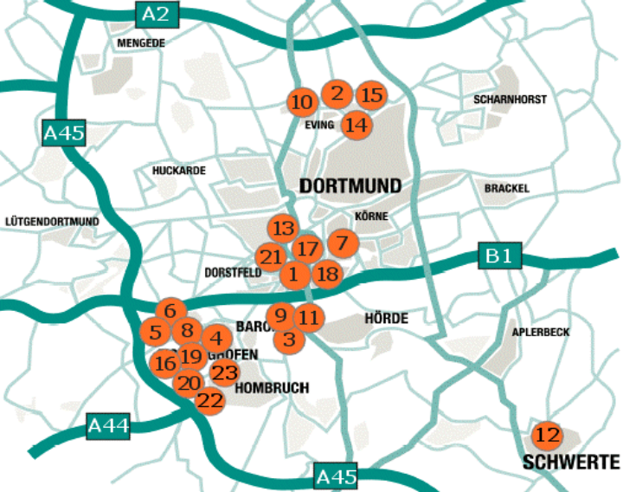
- Fachhochschule Dortmund (FH DO)
- Forschungsgesellschaft für Gerontologie e.V. (FfG)
- Forschungsinstitut für Kinderernährung (FKE)
- Forschungsstelle Ostmitteleuropa an der Universität Dortmund (FOME)
- Fraunhofer-Institut für Materialfluss und Logistik (IML)
- Fraunhofer-Institut für Software und Systemtechnik (ISST)
- Fritz-Hüser-Institut für deutsche und ausländische Arbeiterliteratur der Stadt Dortmund (FHI)
- Hochschule für Musik Detmold, Abteilung Dortmund (HfM)
- Institut für Arbeitsphysiologie an der Universität Dortmund (IfADo)
- Institut für Landes- und Stadtentwicklungsforschung des Landes NRW (ILS)
- Institut für Spektrochemie und Angewandte Spektroskopie (ISAS)
- Institut für Wasserforschung GmbH (IfW)
- Institut für Zeitungsforschung der Stadt Dortmund (IZF)
- Kooperationsstelle Wissenschaft - Arbeitswelt im SFS (kowa)
- Landesinstitut Sozialforschungsstelle (sfs)
- Max-Planck-Institut für molekulare Physiologie (MPI)
- Stadt Dortmund (St DO)
- Stiftung Westfälisches Wirtschaftsarchiv Dortmund (WWA)
- Universität Dortmund (UNI DO)
- Verein zur Förderung der biomedizinischen Wissenschaften in Dortmund e.V. (BIOM)
- Verwaltungs- und Wirtschaftsakademie Dortmund (VWA)
- Erich-Brost-Institut für Journalismus in Europa GmbH (EBI)
- Deutsche Arbeitsschutzausstellung (DASA) der Bundesanstalt für Arbeitsschutz und Arbeitsmedizin (BAuA)
Source: www.windo.de, 06.11.03
In 1992 the scientific institutions have established an organisation called Arbeitsgemeinschaft der Wissenschaftsinstitutionen Dortmund e.V. (windo) (“Association of the Scientific Institutions in Dortmund”) which acts as common platform of the different institutions and aims at promoting Dortmund as a ‘city of science’. One main activity of windo is the organisation of the Wissenschaftstag Dortmund (“Science Day Dortmund”) which takes place ones a year (www.windo.de, 27.10.03).

Dortmund - A Learning City?
The last 40 years Dortmund as well as the whole Ruhr Region have been confronted with challenging economic changes. The region had to pass through an enormous process of transformation with respective consequences for the people, their work and life. Due to changed conditions on the world markets the former so called „Triad of Dortmund“ consisting of coal, steel and beer lost its importance nearly completely (apart from the beer industry).
Meanwhile, city and region have been forced to arrange the changes in a sustainable way and they have not failed. In fact, the transformation process succeeded to a large extent as a result of the efforts of local people and the support from the state of Northrhine-Westphalia and the Federal Government.
Especially Dortmund was able to change its structure successfully. Its economy is shaped by a diverse structured service sector, a strong SME basis and technology oriented businesses. Decisions have been made in a prospective way. The most important one was to strengthen the science basis by establishing universities and research institutes. This basis has become both the main location factor and the initial point for regional innovation and growth. Thus the city has proved that it is able to learn and to renew itself. It is not overstated to call Dortmund a “Learning City”.
Nevertheless Dortmund is not “out of the woods” yet. Further efforts are necessary to close the gap towards German cities and regions. The City likes to be compared with city regions like Stuttgart, Karlsruhe or Munich. Ideas and creativity, courage and endurance are in great demand - even more as in 2005 the “objective 2 program” of the EU by which many projects in Dortmund and the Ruhr Region are still financed will expire. The approach to investigate Dortmund and its (learning) conditions for facing the future challenges is evident.

Bibliography
Brödner, Bruno Heinz, and Armin Rücker. 2003. The Dortmund region. ICT cluster study. Draft version. Dortmund: Department of Spatial Planning in Europe.
Heinze, Rolf G., and Helmut Voelzkow (ed.). 1997. Regionalisierung der Strukturpolitik in NRW, Opladen: Westdeutscher Verlag.
Kunzmann, Klaus R., and Jutta Brosza. 1991. City Case Study: Dortmund. Dortmund: Institut für Raumplanung.
Stadt Dortmund - Statistik und Wahlen. 2003. Jahresbericht 2003: Dortmunder Bevölkerung. Dortmund.
Stadt Dortmund. 2002. Geschäftsbericht 2001/2002. Dortmund
Wirtschafts- und Beschäftigungsförderung Dortmund. 2003a: Geschäftsbericht 2002/2003. Dortmund.
Wirtschafts- und Beschäftigungsförderung Dortmund. 2003b. High-Tech in der Mitte Europas. TechnologiePark Dortmund. Dortmund

