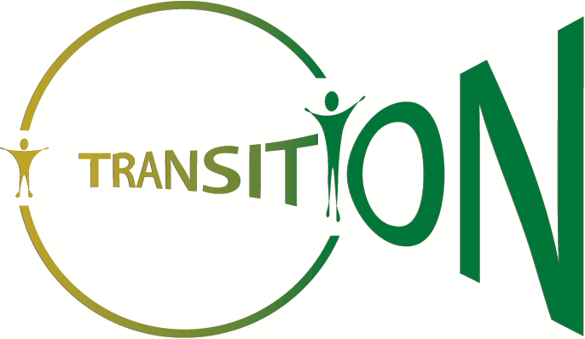

What is the background to the TRANSITION research?

Some young people have support from health services as a teenager, and many will continue to need support from adult health services. We know there is often a gap between the two. Young people may drop out of health services, or be looked after by doctors, nurses and therapists who are not very familiar with their condition. This situation can be bad for young people’s health and wellbeing.
Lots of reports have come out both from the UK and worldwide with suggestions about how to improve things. But what is not known is what young people actually experience in health services as they become a young adult. This research wants to recruit young people aged 14-18 who are receiving health support for autism spectrum disorders, cerebral palsy, or diabetes. If your young person has an autism spectrum disorder and falls in this age range, we would appreciate your involvement in this study.

How is the research likely to be useful?

We want to find out whether the suggestions in reports about how Transition services are useful. For example, does it help if the young person has a written plan for making the transition to adult health services? By finding out what is helpful – for a lot of young people, with a variety of health needs – the research will help ensure that services do what really is best for young people and their families. The NHS has asked the research team to do this research, so it will have an effect on services in future.
What would it involve for you and your child?

Our plan is to be in contact with you and your child once a year for four years. We want to find out how things are going for them. A research assistant will visit your young person at home, school, workplace or other location that he or she decides is most suitable. We have chosen some questionnaires that young people have tried out before, and they take about an hour or less to complete. The questions are about their life, health and preferences for the way services might be organised, and they can fill them in on paper or on-line before the meeting. The reason for visiting once a year to ask the same or similar questions is to see how things have stayed the same or changed. We also have some much shorter questionnaires for a parent (or carer) to complete.

We also want to find out what health and social care services your young person has contact with, and how often. That can be hard to remember after 12 months! We will give you a diary at the first visit, and we would ask you and your child to note down each time they see a doctor, a nurse or any other health or social services professional. The research assistant will also, with your permission, check your young person’s medical notes each time before they come to see you. Then together at the visit you can all work out what took place on the times that your child used health or social services over the previous year.

There is another part of this research study which includes taking part in a more detailed interview with a different research assistant to ask about things such as subjective well-being. This will only be for a few of the young people and their parent/carer in TRANSITION, so if you are interested please ask for more information.

You and your child’s information will be kept private and not shown to anyone - that includes health professionals, teachers, or college staff. When we write a report about the study, we won’t use personal details such as name, address, school, college or work. Your personal details and replies will be kept safe and secure.

If you and your child are interested, please contact:

Ann Le Couteur Tel: 0191 282 1384 Email: a.s.le-couteur@newcastle.ac.uk Institute of Health and Society, Newcastle University, Sir James Spence Institute, Royal Victoria Infirmary, Queen Victoria Road, Newcastle upon Tyne, NE1 4L

You can also contact North of Tyne Patient Advice Liaison Service (PALS) if you have any questions about taking part in research. PALS are not directly involved in the study. They can be contacted by phone on 0800 0320202 or by email at northoftynepals@nhct.nhs.uk

